THIS IS A TRADITIONAL & OPTIONAL ASSIGNMENT… IT MUST BE PRINTED AND COMPLETED IN INK!

Name:_______________________________________ Class Period:____ Due Date:___/____/____
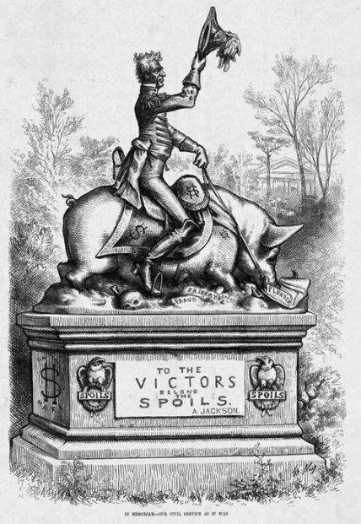
Guided Reading & Analysis: The Age of Jackson, 1824-1844

Chapter 10- Era of the Common Man pp 191-200

Reading Assignment:
Ch. 10 AMSCO or other resource for Period 4 content

Purpose:
This guide is not only a place to record notes as you read, but also to provide a place and structure for
reflections and analysis using higher level thinking skills with new knowledge gained from the reading.

Basic Directions:
- Pre-Read: Read the prompts/questions within this guide before you read the chapter.
- Skim: Flip through the chapter and note the titles and subtitles. Look at images and their
read captions. Get a feel for the content you are about to read.
- Read/Analyze: Read the chapter. Remember, the goal is not to “fish” for a specific answer(s) to
reading guide questions, but to consider questions in order
to critically understand what you read!
- Write Write your notes and analysis in the spaces provided.

(image capturerd from motherjones.com)

Key Concepts FOR PERIOD 4:
Key Concept 4.1: The United States began to develop a modern democracy and celebrated a new national culture, while Americans sought to define the nation’s democratic ideals and change their society and institutions to match them.
Key Concept 4.2: Innovations in technology, agriculture, and commerce powerfully accelerated the American economy, precipitating profound changes to U.S. society and to national and regional identities.
Key Concept 4.3: The U.S. interest in increasing foreign trade and expanding its national borders shaped the nation’s foreign policy and spurred government and private initiatives.

Section 1 Connecting the Era of Good Feelings to the Age of Jackson
Read the summary below. Highlight main ideas.

The War of 1812 ended many of the problems that had plagued the United States since the Revolution. The nation’s independence was confirmed. The long war between Britain and France was over, and with it the need for America to maintain difficult neutrality. The war had convinced Democratic-Republicans that, for the nation’s security, they must protect American industry through tariffs — taxes on imported goods. The Democratic (or Jeffersonian) Republicans even chartered a new national bank to control the nation’s supply of money, something they had vigorously opposed only twenty years before. The Federalist Party, meanwhile, had discredited itself through its opposition to the war (Hartford Convention & Resolutions). As the Jeffersonian Republicans co-opted Federalist positions, the Federalist Party withered away and became essentially extinct outside of New England.

James Monroe presided over the so-called “Era of Good Feelings,” but one-party rule masked serious differences of opinion.

In the elections of 1816, the first after the war’s end, the Republicans took complete control of the federal government. James Monroe succeeded James Madison as President, and the Jeffersonian Republicans won 146 of 185 seats (78%) in the House of Representatives. By Monroe’s second term in office — which he won almost unanimously — the Federalists were reduced to only 4 seats in the U.S. Senate. Monroe’s administration became known as the “Era of Good Feelings” because there was so little opposition to him or to his policies.

Election of 1824…But this one-party system masked real differences in opinion. In 1824, four candidates were nominated to succeed Monroe as President, all calling themselves Democratic-Republicans: the war hero Andrew Jackson, Speaker of the House Henry Clay, Secretary of State John Quincy Adams (pictured), and Secretary of the Treasury William Crawford. None of the candidates won a majority of the electoral vote, and so election was decided by the House of Representatives. Clay had great influence as Speaker of the House, and he threw his support to Adams — some said, in exchange for Adams’ promise to make Clay his Secretary of State. Jackson had won the most electoral votes and the greatest share of the popular vote, and his supporters, who had expected him to be confirmed by the House as President, called this partnership between Adams and Clay a “corrupt bargain.”

During Adams’ administration, his supporters, who included many former Federalists, began to call themselves “National Republicans” to show their support for a strong national government that would promote commerce, support education, and fund roads and canals. But Adams was not particularly popular. In contrast, Jackson was extremely popular, having won national fame as hero of the Battle of New Orleans in the War of 1812 and later in wars against American Indians in Florida. He was also backed by a well-orchestrated political organization. Jackson’s followers formed the Democratic Party, claiming to be the true successors of Jefferson’s Democratic-Republican Party. Like their predecessors, the Democrats believed in small, decentralized government.

Section 2 Guided Reading, pp 191-200
As you read the chapter, jot down your notes in the middle column. Consider your notes to be elaborations on the Objectives and Main Ideas presented in the left column. When you finish the section, analyze what you read by answering the question in the right hand column.

- Jacksonian Democracy pp 191-194

Key Concepts &  Main Ideas | Notes | Analysis
The United States developed the world’s first modern mass democracy and celebrated a new national culture, while Americans sought to define the nation’s democratic ideals and to reform its institutions to match them.  The nation’s transformation to a more participatory democracy was accompanied by continued debates over federal power, the relationship between the federal government and the states, the authority of different branches of the federal government, and the rights and responsibilities of individual citizens. | Jacksonian Democracy…  The Rise of a Democratic Society…  Politics of the Common Man…  Universal Male Suffrage…  Party Nominating Conventions…  Popular Election of the President…  Two-Party System…  Rise of Third Parties…  More Elected Offices…  Popular Campaigning…  Spoils System and Rotation of Officeholders… | Read the first paragraph on page 191. List the three competing viewpoints of Jackson and the emergence of popular politics.  1.  2.  3.  In what ways did Jacksonian Democracy differ from the original republicanism of the Framer’s generation?  1.  2.  3.  To what extent were these differences signs of improving American democracy?  One piece of evidence supporting your answer:  One piece of evidence supporting the opposing view:
Are you using ink? Remember… no pencil!
- Jackson Versus Adams, pp193-194

Key Concepts & Main Ideas | Notes | Analysis
The nation’s transformation to a more participatory democracy was accompanied by continued debates over federal power, the relationship between the federal government and the states, the authority of different branches of the federal government, and the rights and responsibilities of individual citizens. | Jackson Versus Adams…  The Election of 1824…  President John Quincy Adams…  The Revolution of 1828… | Before answering the questions for this section, turn to page 199-200 and read “Historical Perspectives.”  To what extent was the election of 1828 a “revolution?”  Traditional View…  Opposing Whig View…  Arthur M. Schlesinger Jr.’s view…  Contemporary historians…  Recent historians…  Which election was a more significant “revolution” in American politics, 1800 or 1828? Explain your view.  Defend your answer with three pieces of specific historical evidence.  1.  2.  3.

- The Presidency of Andrew Jackson, pp 195-197

Key Concepts & Main Ideas | Notes | Analysis
The nation’s transformation to a more participatory democracy was accompanied by continued debates over federal power, the relationship between the federal government and the states, the authority of different branches of the federal government, and the rights and responsibilities of individual citizens. | The Presidency of Andrew Jackson…  Presidential Power…  Peggy Eaton Affair… | Support or refute Andrew Jackson’s claim that Indian removal was done in the best interest of American Indians.  One piece of evidence supporting your answer:  One piece of evidence supporting the opposing view:  How did the death of Rachel Jackson impact the President?
The Presidency of Andrew Jackson Continued…

Key Concepts  & Main Ideas | Notes | Analysis
Resistance to initiatives for democracy and inclusion included restrictive anti-Indian policies.  Supreme Court decisions sought to assert federal power over state laws and the primacy of the judiciary in determining the meaning of the Constitution.  The nation’s transformation to a more participatory democracy was accompanied by continued debates over federal power, the relationship between the federal government and the states, the authority of different branches of the federal government, and the rights and responsibilities of individual citizens.  Many white Americans in the South asserted their regional identity through pride in the institution of slavery, insisting that the federal government should defend that institution. | Indian Removal Act (1830)…  Trial of Tears…  Nullification Crisis…  1828…  1830…  1832…  1833… Compromise Tariff passed after collaboration between John C. Calhoun and Henry Clay, ending Nullification Crisis | What impact did John Marshall and the Supreme Court have on Indian policy? Explain.  Who had greater power in this era, the Supreme Court or the Executive Branch? Explain.  What other accomplishment in compromise did Henry Clay have (in addition to the Compromise Tariff of 1833) during this Antebellum Era?

Have you figured it out yet? ….. The first major problem Jackson faced as President Nullification Crisis
Before you continue, make sure you thoroughly understand this conflict.

ACTION
Tariff of Abominations, 1828
REACTION
South Carolina Exposition and Protest, 1828
ACTION
South Carolina Exposition and Protest, 1828
REACTION
Webster-Hayne Debate, 1830

REACTIONs
Lowering Tariffs (Tariff of 1832 lowered 1828 tariff from 45% to 35%)
Proclamation to the People of South Carolina, 1832
Force Bill, 1833

ACTION
Ordinance of Nullification, 1832

REACTION
South Carolina rescinded nullification, 1833
ACTION
Henry Clay’s Compromise Tariff of 1833 (eventually lowering tariffs to 10% - same level as 1816)

To what extent did each of the following serve as precedents for the Ordinance of Nullification?

Prior Events | Definition/Description of Event/Document | Extent to which it served as precedent to Ordinance of Nullification
Articles of Confederation |  | __________________ extent, because… (list two reasons)  (large or small)  1.  2.
Whiskey Rebellion |  | __________________ extent, because… (list two reasons)  (large or small)  1.  2.
Virginia and Kentucky Resolutions |  | __________________ extent, because… (list two reasons)  (large or small)  1.  2.
Hartford Resolutions |  | __________________ extent, because… (list two reasons)  (large or small)  1.  2.

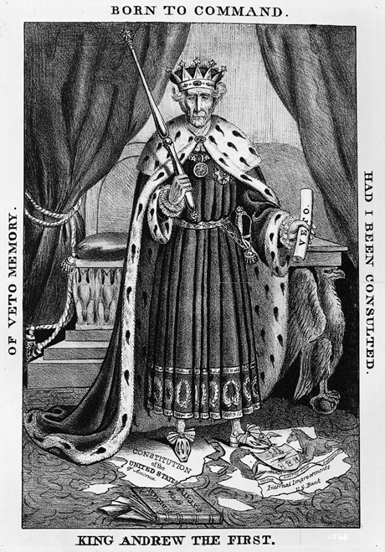
The second major problem Jackson faced as President the Second BUS

BACKGROUND:
Today, the federal government has such power and influence over the nation’s economy that it may be difficult to understand why people were so strongly opposed to a national bank. The first Bank of the United States had been chartered in 1791, under the leadership of Alexander Hamilton. It was a private corporation, only partially owned by the government, and its profits went to stockholders. But the bank had three important and unique privileges. First, the federal government deposited all tax receipts into the bank. Second, the bank made short-term loans to the government. Third, and most important, the national bank refused to accept notes from other banks in individual states unless those banks had enough gold and silver to back up their paper. At that time, all official U.S. money was in coin, but banks issued “bank notes” — pieces of paper with a promise to pay a stated value in gold or silver when they were redeemed or brought back to the bank. These notes could be traded for goods and services, and so they functioned as paper money. If banks issued too much paper money, though, inflation would result — prices would rise, and the dollar would be worth less — and if the banks did not have the assets to back up their promises, people would be left holding worthless paper, the financial system could crash.

To Republicans, though, the bank seemed elitist. Private stockholders earned interest on government deposits. And in the South and West, money had always been in short supply (remember the protests of the Regulators). Southerners and westerners believed that the development of their regions depended on access to money and credit — which the national bank did not give them.

The bank’s charter expired in 1811, and the Republican Congress did not renew it. But the result was just what Hamilton had feared — inflation and confusion over the value of bank notes. To provide for a sound national currency, Congress chartered a second bank of the United States in 1816, again for twenty years. And again, it was resented as elitist — by state and local bankers who resented its privileges, and by people in new states and territories who needed access to money and credit.

When Congress voted to renew the bank’s charter early, President Jackson vetoed the bill with a speech railing against monopoly and privilege. Until that time, presidents had rarely used the veto to override the wishes of Congress. But his veto was popular, and after his re-election in 1832, he issued an executive order ending the deposit of government funds into the Bank of the United States. By issuing an executive order, he was essentially refusing to enforce the act of Congress
that had chartered the bank. Jackson’s acts served as precedents that would concentrate power in the executive branch. This began the Bank War. (In the political cartoon, The cartoon shows Jackson as a king trampling on both the U.S. Bank and the Constitution. He olds a veto in his hand.)

The Presidency of Andrew Jackson Continued…

Key Concepts & Main Ideas | Notes | Analysis
With the acceleration of a national and international market economy, Americans debated the scope of government’s role in the economy, while diverging economic systems meant that regional political and economic loyalties often continued to overshadow national concerns. | Bank Veto … | Was Andrew Jackson more “Jeffersonian” or “Hamiltonian?” Explain.  One specific piece of evidence to support your answer:  One specific piece of evidence to refute your answer:

- The Two Party System, pp 197-199

Key Concepts & Main Ideas | Notes | Analysis
- As various constituencies and interest groups coalesced and defined their agendas, various political parties, most significantly the Federalists and Democratic-Republicans in the 1790s and the Democrats and Whigs in the 1830s, were created or transformed to reflect and/or promote those agendas. | The Two-Party System… | Support or refute the assertion that the Second Two Party System was created by those who supported Jackson versus those who opposed Jackson.

Second Two-Party System OVERVIEW
Democrats v. Whigs, 1836 - 1850
Democrats | Whigs
- The party of tradition.  - Looked backward to the past.  - Spoke to the fears of Americans  - Opposed banks and corporations as. state-legislated economic privilege.  - Opposed state-legislated reforms and preferred individual freedom of choice.  - Were Jeffersonian agrarians who favored farms and rural independence and the right to own slaves.  - Favored rapid territorial expansion over space by purchase or war.  - Believed in progress through external growth.  - Democratic ideology of agrarianism, slavery, states rights, territorial expansion was favored in the South. | - The party of modernization.  - Looked forward to the future.  - Spoke to the hopes of Americans.  - Wanted to use federal and state government to promote economic growth, especially transportation and banks.  - Advocated reforms such as temperance and public schools and prison reform.  - Were entrepreneurs who favored industry and urban growth and free labor.  - Favored gradual territorial expansion over time and opposed the Mexican War.  - Believed in progress through internal growth  - Whig ideology of urbanization, industrialization, federal rights, commercial expansion was favored in the North.

Look at the chart on page 198. Who supported the Democratic Party? Who supported the Whig Party?

What was the most significant point of conflict between these parties?

Mid-19th Century Political Crisis
Disputes over slavery in the territories first erode, then destroy what had become America's second two-party system.
The erosion began in the 1840s as various factions opposed to the post-Jackson Democratic political coalition begin to form.
Third parties reveal conflicts. The third two-party system will solidify in the 1850s.

THIRD PARTIES

Anti-Masonic Party
- Fear of cults, fear of freemasons, fear of secret societies and fraternities
- The first third party in America
- Introduced nominating parties and conventions which were embraced by the main parties
- More regional, starting in NY, in New England, most blended into American Party

The Anti-Masonic Party first appeared in the 1832 presidential elections. This party opposed the influence and secrecy of the Masonic order, a private group renowned for its many famous members. The ideals of the Anti-Masonics were similar to those of the Jacksonians, but since Jackson was himself a member of the Masonic order, the Anti-Masonic party was essentially an anti-Jackson party.
Liberty Party | Free Soil Party
- Run abolitionist candidate James Birney, for president in 1844.  - Won only 2% of the vote but drew votes from the Whigs, especially in New York. | - Not abolitionist but opposed to expansion of slavery in the territories.  - Won 10% of the popular vote with Martin Van Buren as their candidate in 1848.  - Lost 50% of their support in 1852 when their candidate repudiated the Compromise of 1850
Whigs | American Party
Split over slavery into:  - Southern, "Cotton" Whigs who eventually drifted into the Democratic Party.  - Northern, "Conscience" Whigs who moved to new parties, i.e. Free Soil and, later, into the Republican Party. | - Popularly known as the "Know Nothing" Party.  - Nativist party based on opposition to immigration and on temperance.  - Run Millard Fillmore in 1856 and win 21% of the popular vote.  - Absorbed into the Republican Party after 1856.

What were the three main issues that led to the creation of third parties during this Antebellum Era?

- 2. 3.

The Two Party System Continued…

Key Concepts & Main Ideas | Notes | Analysis
As various constituencies and interest groups coalesced and defined their agendas, various political parties, most significantly the Federalists and Democratic-Republicans in the 1790s and the Democrats and Whigs in the 1830s, were created or transformed to reflect and/or promote those agendas. | Jackson’s Second Term…  Pet Banks…  Specie Circular…  The Election of 1836… | Explain the economic impact of Jackson’s Bank Veto, Bank War, and Specie Circular.  In what way does the election of 1836 illustrate the spoils system?

Key Concepts & Main Ideas | Notes | Analysis
- The nation’s transformation to a more participatory democracy was accompanied by continued debates over federal power, the relationship between the federal government and the states, the authority of different branches of the federal government, and the rights and responsibilities of individual citizens.  - Regional interests continued to trump national concerns as the basis for many political leaders’ positions on economic issues including slavery, the national bank, tariffs, and internal improvements. | President Van Buren and the Panic of 1837…  The “Log Cabin and Hard Cider” Campaign of 1840… | Define laissez-faire economics:  Explain how the election of 1840 illustrates the changing politics of the Era of the Common Man.  How did the death of President Harrison impact the Whig Party?

Reading Guide written by Rebecca Richardson, Allen High School
Sources include but are not limited to: 2015 edition of AMSCO’s United States History Preparing for the Advanced Placement Examination,
College Board Advanced Placement United States History Framework, and other sources as cited in document and collected/adapted over 20 years of teaching and collaborating..

