**THIS IS AN OPTIONAL BONUS ASSIGNMENT.**

**PRINT AND COMPLETE IN INK.**

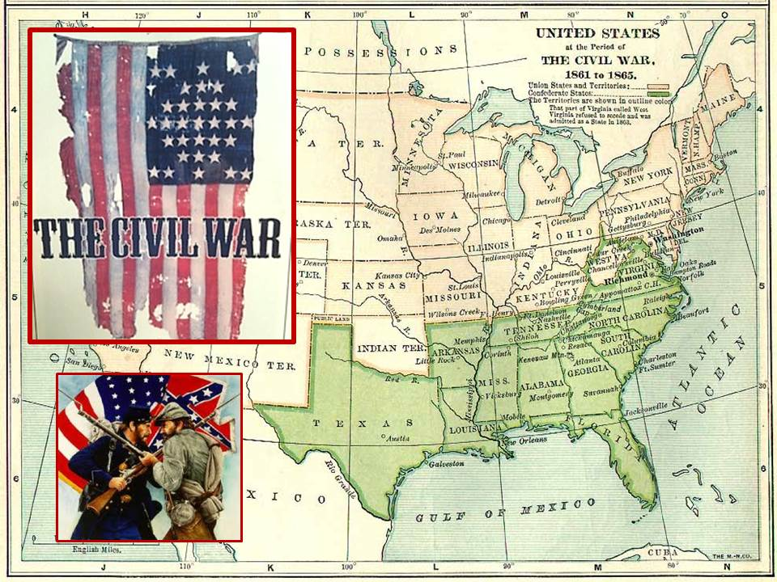

Name:_______________________________________

Class Period:____ Due Date:___/____/____

Guided Reading & Analysis: The Civil War,

1861-1865 chapter 14- *Civil War*  pp 268-283

**Reading Assignment:**

Ch. 14 AMSCO or other resource for Period 5.

**Purpose:**

This guide is not only a place to record notes as you read, but also to provide a

place and structure for *reflections and analysis* using your noggin (thinking skills)

with new knowledge gained from the reading. This guide, **if THOUGHFULLY and**

**ACURATELY completed *in its entirety* BOP (Beginning of Period) by the due date**,

can earn bonus points.The benefits of such activities, however, go far beyond quiz help

and bonus points. ☺ **Mastery of the course and AP exam await all who choose to *process* the information as they read/receive**.

This is an optional assignment. ***So… young Jedi… what is your choice? Do? Or do not? There is no try.***

**(collage created by Rebecca Richardson using playbill from**

***The Civil War*, map from wiki commons, and image from artshound)**

**Directions:**

1. **Pre-Read:** Read the prompts/questions within this guide before you read the chapter.
2. **Skim:** Flip through the chapter and note titles and subtitles. Look at images and read captions. *Get a feel for the content you are about to read.*
3. **Read/Analyze:** Read the chapter. If you have your own copy of AMSCO, Highlight key events and people as you read. Remember, the goal is not

to “fish” for a specific answer(s) to reading guide questions, but to ***consider questions in order to critically understand what you read***!

1. **Write:**  Write (do not type) your notes and analysis in the spaces provided. Complete it in ***INK!***

**Key Concepts FOR PERIOD 5:**

**Key Concept 5.1:** The United States became more connectedwith the world, pursued an expansionist foreign policy in the Western Hemisphere, and emerged as the destination for many migrants from other countries.

**Key Concept 5.2:** Intensified by expansion and deepeningregional divisions, debates over slavery and other economic, cultural, and political issues led the nation into civil war.

**Key Concept 5.3:** The Union victory in the Civil War and thecontested reconstruction of the South settled the issues of slavery and secession, but left unresolved many questions about the power of the federal government and citizenship rights.

**Section 1 Guided Reading, pp 268-282**

1. **Intro: The Civil War, 1861-1865 page 268**

|  |  |
| --- | --- |
| **Key Concepts &**  **Main Ideas** | **Notes** |
| The **North**’s greater manpower and industrial resources, its leadership, and the decision for emancipation eventually led to the Union military victory over the **Confederacy** in the devastating **Civil War**  The **Union** victory in the **Civil War** and the contested **Reconstruction** of the South settled the issues of **slavery** and **secession**… | **Read the William Tecumseh Sherman quote and first paragraph of the chapter on page 268.**  **List and explain the four main ways the civil war impacted the nation.**  **1)**  **2)**  **3)**  **4)**  **Which effect of war do you view as the most significant? Explain your reasoning.** |

1. **The War Begins pp 268-271**

**REMEMBER…As you read the chapter, jot down your notes in the middle column. Consider your notes to be elaborations on the Objectives and Main Ideas presented in the left column and in the subtitles of the text. INCLUDE IN YOUR NOTES ALL SIGNIFICANT VOCABULARY AND PEOPLE. After read and take notes, *thoughtfull*y, analyze what you read by answering the questions in the right column. Remember this step is essential to your *processing* of information. Completing this guide *thoughtfully* will increase your retention as well as your comprehension!**

|  |  |  |
| --- | --- | --- |
| **Key Concepts & Main Ideas** | **Notes** | **Analysis** |
| The **North**’s greater manpower and industrial resources, its leadership, and the decision for emancipation eventually led to the Union military victory over the **Confederacy** in the devastating **Civil War.**  Although **Confederate leadership** showed initiative and daring early in the war, the **Union** ultimately succeeded due to improved military leadership, more effective strategies, key victories, greater resources, and the wartime destruction of the South’s environment and infrastructure. | **The War Begins…**  **Fort Sumter…**  **Use of Executive Power…**  **Secession of the Upper South…**  **Keeping Border States in the Union…**  **Wartime Advantages…**  **Military…**  **Economic…**  **Political…**  **The Confederate States of America…** | **Abraham Lincoln is revered at one of the best Presidents in history by many historians; however there are those who see him as a tyrant who abused his power. Support or refute the assertion that he was a tyrant who violated the Constitution and individuals’ rights as outlined in the Bill of Rights. Defend your answer with specific evidence.**  **Abraham Lincoln said, “I hope to have God on my side, but I must have Kentucky.” What did he mean by this?**  **So many West Point graduates joined the Confederacy, the government contemplated shutting it down. (Of 1,108 U.S. Army officers in 1860, only 270 resigned to join the Confederate Army. Of those 270, however, 184 were West Point graduates and were mostly middle to upper commanders with military experience… most notably, Robert E. Lee.) Despite so many highly trained military leaders, they still ended up losing. Why do you think that was?** |

1. **First Years of a Long War, pp 271-2273**

|  |  |  |
| --- | --- | --- |
| **Key Concepts & Main Ideas** | **Notes** | **Analysis** |
| Although **Confederate leadership** showed initiative and daring early in the war, the **Union** ultimately succeeded due to improved military leadership, more effective strategies, key victories, greater resources, and the wartime destruction of the South’s environment and infrastructure. | **First Years of a Long War…**  **First Battle of Bull Run…**  **Union Strategy…**  **Peninsula Campaign…**  **Second Battle of Bull Run…**  **Antietam…..**  **Fredericksburg…**  **Monitor vs. Merrimac…**  **Grant in the West…** | **Who had more victories in the first years of the war?**  **Explain how technological innovation impacted the war.**  **General Winfield Scott’s strategy turned out to be the winning strategy, although it wasn’t taken seriously at the time. Explain why it was mocked early on in the war.**  **How was General Grant different from General McClellen?** |

1. **Foreign Affairs and Diplomacy and The End of Slavery, pp 274-276**

|  |  |  |
| --- | --- | --- |
| **Key Concepts**  **& Main Ideas** | **Notes** | **Analysis** |
| The **North**’s greater manpower and industrial resources, its leadership, and the decision for emancipation eventually led to the Union military victory over the **Confederacy** in the devastating **Civil War.**  **Lincoln**’s decision to issue the **Emancipation Proclamation** changed the purpose of the war, enabling many **African Americans** to fight in the **Union Army**, and helping prevent the **Confederacy** from gaining full diplomatic support from **European powers**.  The **13th Amendment** abolished slavery, bringing about the war’s most dramatic social and economic change… | **Foreign Affairs and Diplomacy…**  **Trent Affair…**  **Confederate Raiders…**  **Failure of Cotton Diplomacy…**  **The End of Slavery…**  **Confiscation Acts…**  **Emancipation Proclamation…**  **Consequences…**  **Thirteenth Amendment…**  **Freedmen in the War…** | **Explain why the South failed to develop an alliance with Great Britain.**  **To what extent was the Emancipation Proclamation responsible for the South’s failed “cotton diplomacy?” Defend your answer.**  **In what way was the Battle of Antietam a turning point in the war?**  **Explain the significance of the 54th Regiment. #*Glory*** |

1. **The Union Triumphs, 1863-1865 pp 277-279**

|  |  |  |
| --- | --- | --- |
| **Key Concepts & Main Ideas** | **Notes** | **Analysis** |
| The **North**’s greater manpower and industrial resources, its leadership, and the decision for emancipation eventually led to the Union military victory over the **Confederacy** in the devastating **Civil War.**  Although **Confederate leadership** showed initiative and daring early in the war, the **Union** ultimately succeeded due to improved military leadership, more effective strategies, key victories, greater resources, and the wartime destruction of the South’s environment and infrastructure. | **The Union Triumphs, 1863-1865…**  **Turning Point**  **Vicksburg**  **Gettysburg…**  **Grant in Command…**  **Sherman’s March…**  **Election of 1864…**  **The End of the War…**  **Surrender at Appomattox…**  **Assassination of Lincoln…** | **Support or refute the assertion that the Battle of Gettysburg was a more important turning point than the Battle of Vicksburg.**  **Which turning point Battle was most essential in implementing General Winfield Scotts war strategy?**  **Explain the political impact of Sherman’s March to the Sea.**  **Was Lincoln a popular president (while serving as President)? Defend your answer with evidence.**  **Why did General Grant treat General Lee with such respect at the end of the war? What is significant about this?** |

1. **Effects of the War on Civilian Life, pp 279-282**

|  |  |  |
| --- | --- | --- |
| **Key Concepts & Main Ideas** | **Notes** | **Analysis** |
| The **Union** victory in the **Civil War** and the contested **Reconstruction** of the South settled the issues of **slavery** and **secession**, but left unresolved many questions about the power of the **federal government** and **citizenship rights**.  The **Civil War** … altered **power relationships** between the states and the federal government and among the executive, legislative, and judicial branches, ending **slavery** and the notion of a **divisible union**, but leaving unresolved questions of relative power and largely unchanged **social and economic patterns**. | **Effects of the War on Civilian Life…**  **Political Change…**  **Civil Liberties…**  ***Ex Parte Milligan…***  **The Draft…**  **Political Dominance of the North…**  **Economic Change…**  **Financing the War…** | **What is the difference between a scalawag and a copperhead?**  **Explain how the Union victory impacted federal politics and regional economics.**  **Both the North and the South experienced inflation due to the war (and spending). Why was inflation so much higher in the South?** |

**Effects of the War on Civilian Life Continued…**

|  |  |  |
| --- | --- | --- |
| **Key Concepts & Main Ideas** | **Notes** | **Analysis** |
| The **Union** victory in the **Civil War** and the contested **Reconstruction** of the South settled the issues of **slavery** and **secession**, but left unresolved many questions about the power of the **federal government** and **citizenship rights**.  (this section will be more relevant in the next era) | **Modernizing Northern Society…**  ***While the Democrats are away… the Republicans will play…***   1. **Morrill Tariff Act** 2. **Homestead Act** 3. **Morrill Land Grant Act** 4. **Pacific Railway Act**   **Social Change…**  **End of Slavery…** | **Support or refute the assertion that the Civil War was a Second American Revolution. Back up your answer with evidence.**  **Compare and contrast the effect of War on women to the effect of War on African Americans.** |

**Historical Context (BROAD)**

**& Intended Audience,**

**Purpose, or Point of View**

**H:**

**IPP:**

**Contextualize & Analyze the following:**

**Address Delivered at the Dedication of the Cemetery at Gettysburg Abraham Lincoln November 19, 1863**

Four score and seven years ago our fathers brought forth on this continent, a new nation, conceived in Liberty, and dedicated to the proposition that all men are created equal. Now we are engaged in a great civil war, testing whether that nation, or any nation so conceived and dedicated, can long endure. We are met on a great battle-field of that war. We have come to dedicate a portion of that field, as a final resting place for those who here gave their lives that that nation might live. It is altogether fitting and proper that we should do this. But, in a larger sense, we can not dedicate -- we can not consecrate -- we can not hallow -- this ground. The brave men, living and dead, who struggled here, have consecrated it, far above our poor power to add or detract. The world will little note, nor long remember what we say here, but it can never forget what they did here. It is for us the living, rather, to be dedicated here to the unfinished work which they who fought here have thus far so nobly advanced. It is rather for us to be here dedicated to the great task remaining before us -- that from these honored dead we take increased devotion to that cause for which they gave the last full measure of devotion -- that we here highly resolve that these dead shall not have died in vain -- that this nation, under God, shall have a new birth of freedom -- and that government of the people, by the people, for the people, shall not perish from the earth.

1. **Historical Perspectives: Why Did the Union Win? Page 283**

|  |  |  |  |
| --- | --- | --- | --- |
| **Political Reasons…** | **Economic Reasons…** | **Demographic Reasons…** | **Cultural Reasons…** |

|  |
| --- |
| **Which factor do you see as most significant to the Confederate loss? Explain your choice.** |

**Historical Context (BROAD)**

**& Intended Audience,**

**Purpose, or Point of View**

**H:**

**IPP:**

**Contextualize & Analyze the following:**

I here declare my unmitigated hatred to Yankee rule -- to all political, social and business connection with the Yankees and to the Yankee race. Would that I could impress these sentiments, in their full force, on every living Southerner and bequeath them to every one yet to be born! May such sentiments be held universally in the outraged and down-trodden South, though in silence and stillness, until the now far-distant day shall arrive for just retribution for Yankee usurpation, oppression and atrocious outrages, and for deliverance and vengeance for the now ruined, subjugated and enslaved Southern States!

...And now with my latest writing and utterance, and with what will be near my latest breath, I here repeat and would willingly proclaim my unmitigated hatred to Yankee rule--to all political, social and business connections with

Yankees, and the perfidious, malignant and vile Yankee race."

--*Edmund Ruffin*

*(June 18, 1865* His lasts words before he committed suicide saying he’d rather die than live under Yankee rule.)

**Taking into consideration Edmund Ruffin’s comments (he, by the way, fired the first shot at Fort Sumter), how did the Civil War impact the relationship between the North and the South?**

**Reading Guide written by Rebecca Richardson, Allen High School**

Sources include but are not limited to: 2015 edition of AMSCO’s *United States History Preparing for the Advanced Placement Examination*, 2012 & 2015 Revised College Board Advanced Placement United States History Framework,

*The Mental Floss History of the United States* by Erik Sass*, HIPP writing strategy developed by John P. Irish, Carroll High School, and other sources as cited in document and collected/adapted over 20 years of teaching and collaborating..*