Analyzing an Image

1. Describe what is happening in the picture.

2. What does the woman represent?

3. What does the dark and light imply?

4. What does the author want you to notice, think, and feel? (Audience & Purpose)

5. What is the painter’s opinion about westward expansion? How do you know? (Point of View)

6. What does this picture imply about the time period? (Historical Context & Why is this important?)

Analyzing a Map
“To present a picture of it was desirable in every point of view. The map so constructed, shows at a glance the whole extent of the United States territory from sea to sea; and in tracing the probable expansion of the human race from east to west, the mind finds an agreeable resting place on its western limits. The view is complete, and leaves nothing to be wished for. It also adds to the beauty and symmetry [balance] of the map; which will, it is confidently believed, be found one of the most useful and ornamental [decorative] works ever executed [created] in this country.” –John Melish, 1816
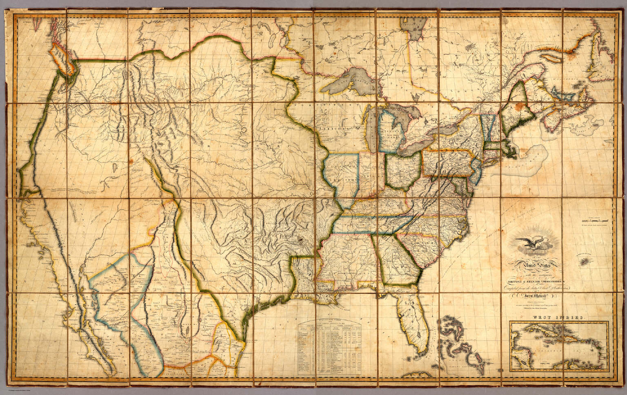
1. According to Melish, why did he decide to draw the map of the United States this way?

2. How does this relate to Manifest Destiny?

3. How does this relate to this time period?

Analyzing a Document
John L. O'Sullivan on Manifest Destiny, 1839

Excerpted from "The Great Nation of Futurity," The United States Democratic Review, Volume 6, Issue 23, pp. 426-430. The complete article can be found in The Making of America Series at Cornell University

The American people having derived their origin from many other nations, and the Declaration of National Independence being entirely based on the great principle of human equality, these facts demonstrate at once our disconnected position as regards any other nation; that we have, in reality, but little connection with the past history of any of them, and still less with all antiquity, its glories, or its crimes. On the contrary, our national birth was the beginning of a new history, the formation and progress of an untried political system, which separates us from the past and connects us with the future only; and so far as regards the entire development of the natural rights of man, in moral, political, and national life, we may confidently assume that our country is destined to be the great nation of futurity.
It is so destined, because the principle upon which a nation is organized fixes its destiny, and that of equality is perfect, is universal. It presides in all the operations of the physical world, and it is also the conscious law of the soul -- the self-evident dictates of morality, which accurately defines the duty of man to man, and consequently man's rights as man. Besides, the truthful annals of any nation furnish abundant evidence, that its happiness, its greatness, its duration, were always proportionate to the democratic equality in its system of government. . . .
What friend of human liberty, civilization, and refinement, can cast his view over the past history of the monarchies and aristocracies of antiquity, and not deplore that they ever existed? What philanthropist can contemplate the oppressions, the cruelties, and injustice inflicted by them on the masses of mankind, and not turn with moral horror from the retrospect?
America is destined for better deeds. It is our unparalleled glory that we have no reminiscences of battle fields, but in defence of humanity, of the oppressed of all nations, of the rights of conscience, the rights of personal enfranchisement. Our annals describe no scenes of horrid carnage, where men were led on by hundreds of thousands to slay one another, dupes and victims to emperors, kings, nobles, demons in the human form called heroes. We have had patriots to defend our homes, our liberties, but no aspirants to crowns or thrones; nor have the American people ever suffered themselves to be led on by wicked ambition to depopulate the land, to spread desolation far and wide, that a human being might be placed on a seat of supremacy.
We have no interest in the scenes of antiquity, only as lessons of avoidance of nearly all their examples. The expansive future is our arena, and for our history. We are entering on its untrodden space, with the truths of God in our minds, beneficent objects in our hearts, and with a clear conscience unsullied by the past. We are the nation of human progress, and who will, what can, set limits to our onward march? Providence is with us, and no earthly power can. We point to the everlasting truth on the first page of our national declaration, and we proclaim to the millions of other lands, that "the gates of hell" -- the powers of aristocracy and monarchy -- "shall not prevail against it."
The far-reaching, the boundless future will be the era of American greatness. In its magnificent domain of space and time, the nation of many nations is destined to manifest to mankind the excellence of divine principles; to establish on earth the noblest temple ever dedicated to the worship of the Most High -- the Sacred and the True. Its floor shall be a hemisphere -- its roof the firmament of the star-studded heavens, and its congregation an Union of many Republics, comprising hundreds of happy millions, calling, owning no man master, but governed by God's natural and moral law of equality, the law of brotherhood -- of "peace and good will amongst men.". . .
Yes, we are the nation of progress, of individual freedom, of universal enfranchisement. Equality of rights is the cynosure of our union of States, the grand exemplar of the correlative equality of individuals; and while truth sheds its effulgence, we cannot retrograde, without dissolving the one and subverting the other. We must onward to the fulfilment of our mission -- to the entire development of the principle of our organization -- freedom of conscience, freedom of person, freedom of trade and business pursuits, universality of freedom and equality. This is our high destiny, and in nature's eternal, inevitable decree of cause and effect we must accomplish it. All this will be our future history, to establish on earth the moral dignity and salvation of man -- the immutable truth and beneficence of God. For this blessed mission to the nations of the world, which are shut out from the life-giving light of truth, has America been chosen; and her high example shall smite unto death the tyranny of kings, hierarchs, and oligarchs, and carry the glad tidings of peace and good will where myriads now endure an existence scarcely more enviable than that of beasts of the field. Who, then, can doubt that our country is destined to be the great nation of futurity?

1. What does John O’Sullivan think America stands for? (Point of View)

2. What, according to John O’Sullivan, is America’s mission?

The American Yawp Reader

John O’Sullivan Declares America’s Manifest Destiny, 1845
John Louis O’Sullivan, a popular editor and columnist, articulated the long-standing American belief in the God-given mission of the United States to lead the world in the transition to democracy. He called this America’s “manifest destiny.” This idea motivated wars of American expansion. He explained this idea in the following essay where he advocated adding Texas to the United States.
Texas is now ours… Her star and her stripe may already be said to have taken their place in the glorious blazon of our common nationality; and the sweep of our eagle’s wing already includes within its circuit the wide extent of her fair and fertile land. She is no longer to us a mere geographical space–a certain combination of coast, plain, mountain, valley, forest and stream. She is no longer to us a mere country on the map. She comes within the dear and sacred designation of Our Country… other nations have undertaken to intrude themselves … in a spirit of hostile interference against us, for the avowed object of thwarting our policy and hampering our power, limiting our greatness and checking the fulfillment of our manifest destiny to overspread the continent allotted by Providence for the free development of our yearly multiplying millions. This we have seen done by England, our old rival and enemy; and by France, strangely coupled with her against us…
The independence of Texas was complete and absolute. It was an independence, not only in fact, but of right. No obligation of duty towards Mexico tended in the least degree to restrain our right to effect the desired recovery of the fair province once our own–whatever motives of policy might have prompted a more deferential consideration of her feelings and her pride, as involved in the question. If Texas became peopled with an American population; it was by no contrivance of our government, but on the express invitation of that of Mexico herself…
California will, probably, next fall away from the loose adhesion which, in such a country as Mexico, holds a remote province in a slight equivocal kind of dependence on the metropolis. Imbecile and distracted, Mexico never can exert any real governmental authority over such a country. The impotence of the one and the distance of the other, must make the relation one of virtual independence; unless, by stunting the province of all natural growth, and forbidding that immigration which can alone develop its capabilities and fulfil the purposes of its creation, tyranny may retain a military dominion, which is no government in the, legitimate sense of the term. In the case of California this is now impossible. The Anglo-Saxon foot is already on its borders. Already the advance guard of the irresistible army of Anglo-Saxon emigration has begun to pour down upon it, armed with the plough and the rifle, and marking its trail with schools and colleges, courts and representative halls, mills and meeting-houses. A population will soon be in actual occupation of California, over which it will be idle for Mexico to dream of dominion. They will necessarily become independent. All this without agency of our government, without responsibility of our people–in the natural flow of events, the spontaneous working of principles, and the adaptation of the tendencies and wants of the human race to the elemental circumstances in the midst of which they find themselves placed. And they will have a right to independence–to self-government–to the possession of the homes conquered from the wilderness by their own labors and dangers, sufferings and sacrifices-a better and a truer right than the artificial tide of sovereignty in Mexico, a thousand miles distant, inheriting from Spain a title good only against those who have none better. Their right to independence will be the natural right of self-government belonging to any community strong enough to maintain it–distinct in position, origin and character, and free from any mutual obligations of membership of a common political body, binding it to others by the duty of loyalty and compact of public faith. This will be their title to independence; and by this title, there can be no doubt that the population now fast streaming down upon California win both assert and maintain that independence. Whether they will then attach themselves to our Union or not, is not to be predicted with any certainty. Unless the projected railroad across the continent to the Pacific be carried into effect, perhaps they may not; though even in that case, the day is not distant when the Empires of the Atlantic and Pacific would again flow together into one, as soon as their inland border should approach each other. But that great work, colossal as appears the plan on its first suggestion, cannot remain long unbuilt. Its necessity for this very purpose of binding and holding together in its iron clasp our fast-settling Pacific region with that of the Mississippi valley–the natural facility of the route–the ease with which any amount of labor for the construction can be drawn in from the overcrowded populations of Europe, to be paid in die lands made valuable by the progress of the work itself–and its immense utility to the commerce of the world with the whole eastern Asia, alone almost sufficient for the support of such a road–these coast of considerations give assurance that the day cannot be distant which shall witness the conveyance of the representatives from Oregon and California to Washington within less time than a few years ago was devoted to a similar journey by those from Ohio; while the magnetic telegraph will enable the editors of the “San Francisco Union,” the “Astoria Evening Post,” or the “Nootka Morning News,” to set up in type the first half of the President’s Inaugural before the echoes of the latter half shall have died away beneath the lofty porch of the Capitol, as spoken from his lips.
Away, then, with all idle French talk of balances of power on the American Continent. There is no growth in Spanish America! Whatever progress of population there may be in the British Canadas, is only for their own early severance of their present colonial relation to the little island three thousand miles across the Atlantic; soon to be followed by Annexation, and destined to swell the still accumulating momentum of our progress. And whosoever may hold the balance, though they should cast into the opposite scale all the bayonets and cannon, not only of France and England, but of Europe entire, how would it kick the beam against the simple, solid weight of the two hundred and fifty, or three hundred millions–and American millions–destined to gather beneath the flutter of the stripes and stars, in the fast hastening year of the Lord 1945!
John O’Sullivan, “Annexation,” The United States Magazine and Democratic Review, Volume 17 (New York: 1845), 5-6, 9-10.
1. What do you think John O’Sullivan means by “our manifest destiny to overspread the continent allotted by Providence for the free development of our yearly multiplying millions”? (Point of View)

2. Based on these two documents, how did Americans feel about expanding westward? (Audience)

3. What does this tell us about the time period? (Historical Context)

