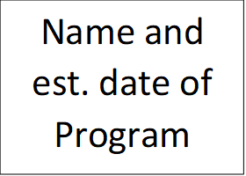

Description of the program

Critics to the program & what they had issue with

Each box, except for the center, should have a clearly written explanation and colorful illustration

Short term & long term effects of the program

Who it was aiming to support

What problem it was trying to address

Name and est. date of Program