A Picture’s Worth a Thousand Words Final Project

Since Matthew Brady’s photography of the Civil War, images have been a growing source of information and emotive power. Motion picture and video has since revolutionized the way we examine and form a perception of a particular event. Your task in this project is to find an historically significant photo or a still from a video image and create a museum style exhibit. The exhibit will require significant research in order to complete the following:

- A quality image at least 8 ½ by 11. If you can produce it in a larger form that is great but be sure the image is acceptable quality. Points will be deducted for images with poor visual quality.

- A title which will cleverly describe the project

- A setting/plot caption which appropriately sets the stage for the event – In other words what is the historical context of the moment or topic being captured.

- Character caption(s) which provide detail on who the people are and what brought them to this moment in history. In some cases this may be difficult. If you feel you exhaust every reasonable attempt to find out specifically who these people were then focus on who or what they represent from their time period. If there are no period than discuss the structure or other main topic of the image.

- Original intent of the photograph or still image. Who was the photographer? What publication or broadcast was it used for? Did it win any awards? It is possible that an image has been numerous times, but please try your best to find the original photographer. It takes a lot of Google Searching, but it is actually possible to do an image search on Google – use this to help you find the original.

- Immediate and Lasting Impact Caption: First, What was the reaction of the viewers at the time? For this you may wish to interview people you know to get their reactions to seeing it for the first time. Then, assess its current impact. For this you may wish to present the image to your peers and get a sense of their reaction and/or context of where they may have seen it for the first time.

- A Where Are They Now or Where did They Go From Here/Epilogue caption. Where did these people go after the events captured in the photo? Did they go on to bigger and better things? Do they look back on the event with nostalgia? Was it an event that they wish was never revisited? IF you don’t know who the people are for sure, think about how things changed since this photo was taken.

- A Remember When caption. This caption is the “family bio” portion of the project. You must find someone old enough to at least remember the 1960s or were at least a teenager when the event occured. You must interview someone and ask them about the people in the image and any related events. This caption must also put the entire times in perspective. What was your interviewee’s perception of the social, political, and/or economic historical context of the time – not just of the image itself!

This will require research and therefore a works cited caption, MLA format of course. Remember your oral history interview is also a source to be cited. Choose wisely and have some fun with it!
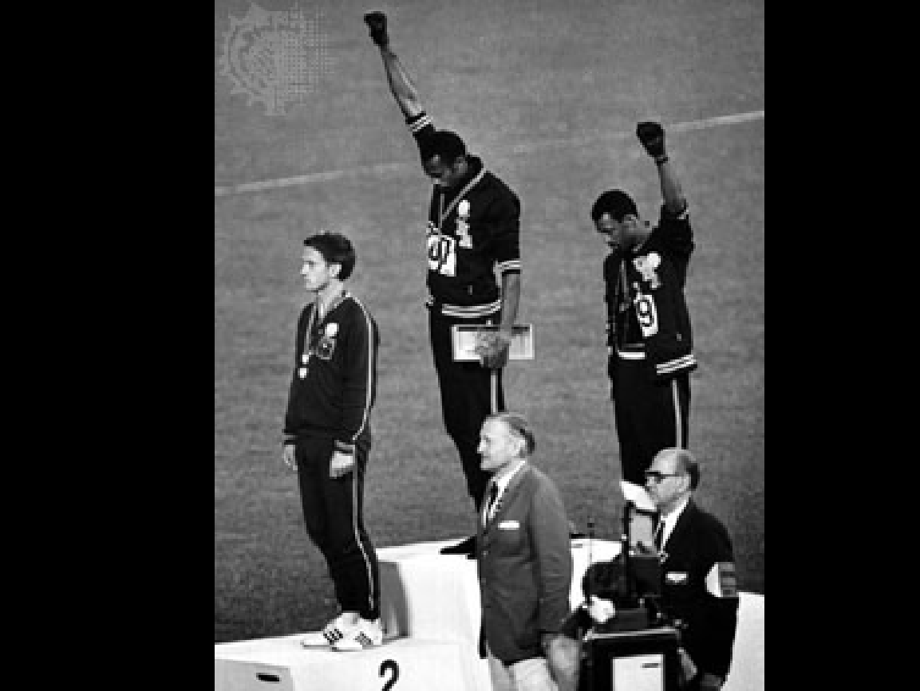

Picture’s Worth a Thousand Words Project Due Dates

Image Selection Friday, May 24, 2019

Drafts of Three Captions and Works Cited Tuesday, May 28, 2019

Final Project Thursday, May 30 (100 PTS)

Rubric Categories
Excellent: 100-95
Good: 94 - 85
Satisfactory: 84 - 75
Poor: 74 - 65
Unacceptable: 65-50

Organization and Creativity: Extremely well designed. Attention to detail in the areas of layout, spacing. Image is clear. General appearance is engaging to the viewer. Was extremely clever and presented with originality; unique approach and coverage of the event and people enhances the project

Content: Completely accurate; all facts are precise and explicit; author conveys a knowledge of the event and its short and long term consequences. Author clearly conveys the mutual impact of both the event and the people affected by the event.

Research: Went above and beyond to research info; utilized both primary and secondary sources; solicited material in addition to that which would be readily available in a text or general reference. Research was balanced and thorough for all major features of the project

Oral History: Project reflects rich oral history interviewing. The interview reflects both recollections of the specific people and event as well as the person’s perception of the social, political, and/or economic historical context of the times. Goes beyond a quick quote, but shows that a deep discussion occurred between interviewer and interviewee.

Mechanics: All written work follows the conventions for standard English grammar, syntax and spelling. PROPER MLA FORMAT and CITATIONS. Incorrect or missing format = F=ZERO

