APUSH
Period 4
Expansion and Reform 1800 - 1848
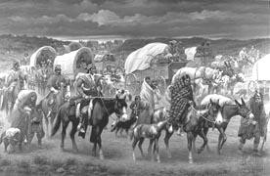
“The Trail of Tears” by Robert Lindneux

Goal: Expansion and Reform (1800-1850) - The learner will assess the competing forces of expansionism, nationalism, and sectionalism.

- Amsco chapters 7, 8, 9, 10 AND 11

Objectives
  - The US developed the world first modern mass democracy, celebrated a new national culture and sought to define the nation’s democratic ideals.
  - Developments in technology, agriculture and commerce created profound changes in settlement patterns, political power, and distribution of consumer goods and shaped the role of families.
  - US interested in foreign trade, expanding national borders and isolating itself from European conflicts shaped the future role of the national government and private enterprises.

The Era Begins with the Revolution of 1800!
- The election of 1800 … aka The Revolution of 1800
- Thomas Jefferson – 3rd President of the United States

Aaron Burr and Thomas Jefferson received identical electoral votes, so the election was sent to the House of Representatives, which selected T.J. To solve the problem, the 12th Amendment was passed in 1804a
Read the quote from Jefferson’s Inaugural Address and the first two paragraphs on page 131. Explain the historical significance of the election and his call to lead the nation into the next century.
What did America look like in 1800?
Shade British Territory in yellow Shade Spanish Territory in green Shade French Territory in blue Label remaining states
Label Ohio River, Mississippi River, Atlantic Ocean, Gulf of Mexico

- France lost all of its Louisiana Territory in 1763, why did they lose it?

- Why did Spain gain it?

- Why did possession of Louisiana transfer back to France (hint: google Treaty of Ildefonso)
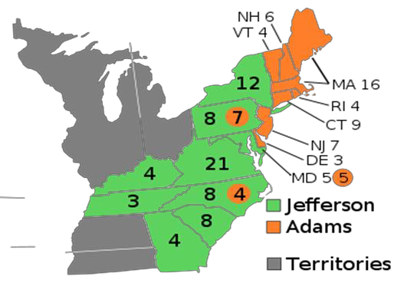
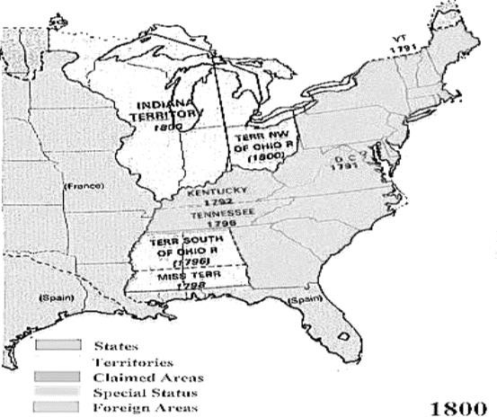
Election of 1800
Political Party | Federalist | Democratic-Republican
Candidate | John Adams | Thomas Jefferson
From | Massachusetts | Virginia
Electoral Votes | 65 | 73
Outcome | Lost & Bitter | President with Aaron  Burr as Vice President

The development of Jeffersonian Democracy in America begins with the election of 1800. At the time, this election was in all the newspapers, each side was throwing around negative comments and propaganda in order to persuade the voters to elect their candidate. The 2016 election is extremely charged with Hillary and Trump throwing everything they have at each other in order to persuade voters.

https://www.youtube.com/watch?v=2Drl8fpWTKo&app=desktop 1800

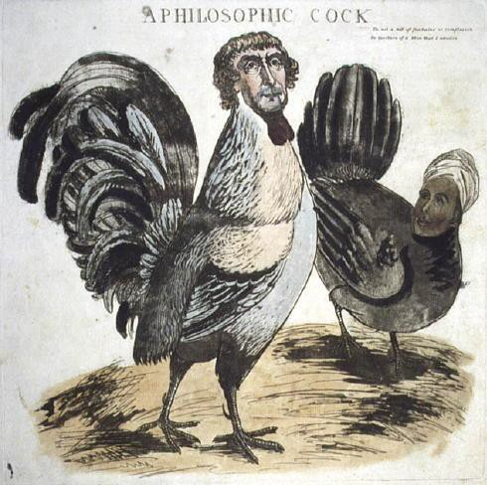
http://www.theatlantic.com/video/index/262115/60-years-of-presidential-attack-ads-in-one-video/ last 60 years

Jefferson – sleeping with his slave!

Sally Hemmings – Jefferson was under fire by the federalists. He was accused of having illegitimate mulatto children with one of his slaves, Sally Hemmings; his wife had died and he had promised her he would never remarry (Sally was the half-sister of his wife). He did have a long relationship with Sally – proven with DNA – but at the time it was more of a salacious story/humor. The historical analysis of their relationship varies from true love to abusive master.

Most of the political attack ads concerning Hemmings came after the election, but Adams did try to capitalize on the rumors by supporting “whispering campaigns” to further spread them.

In the image to the left, Jefferson is portrayed as a rooster and Hemmings is a hen. The rooster was a symbol of revolutionary France. What is the significance of France in the election campaign?

Among other things, Jefferson was accused of being an atheist, and what does that reveal about politics and culture of the time? Compare the role of religion in our political debates today?

Election Year | Who Won & Political party | Years Served | 2 Domestic policies | 2 Foreign policies

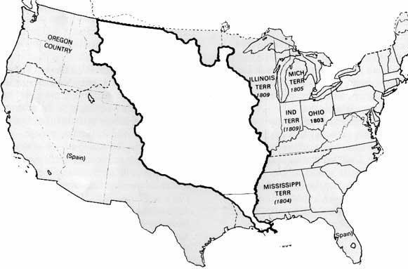

What did America look like in 1803?

Label the Pacific & Atlantic Oceans, Label the Gulf of Mexico
Label the Louisiana Territory and remaining states, highlight the United States (in 1803) in Yellow

“This accession of territory affirms forever the power of the United States,
And I have given England a maritime rival who sooner or later will humble her pride.”
Napoleon Bonaparte, 1804

Evaluate how did the Haitian Revolution impact this purchase? Provide a minimum of 5 complete sentences.

The Age of Jefferson, 1800 to 1816: Jefferson’s Presidency

In 1787 the Articles of Confederation were discarded and the Constitution became the law of the land. It created a bicameral legislature, three branches of government, and the division of power between the states and the federal government (aka, Federalism). The Bill of Rights also established many basic freedoms central to the identity of the United States. During the presidency of Washington, Jefferson and Hamilton expressed different visions of America, thus creating the formation of political parties.

With the election of Jefferson in 1800, his vision of America differed greatly from that of the previous Federalist presidents.

Political Party Platform | Federalists | Democratic-Republicans
Domestic issues
Foreign Affairs
Economics
Constitution

US interests were increasing in regards to foreign trade, expanding its national borders and isolating itself from European conflicts – thus shaping the nation’s foreign policy and spurred government and private initiatives.

Explain in three sentences the significance of Jefferson’s repeal of the whiskey tax?
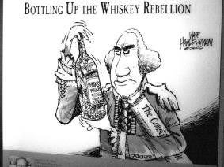

List 3 reasons for the Louisiana Purchase: 1)
2)
3)

Was the Louisiana Purchase Jeffersonian or Hamiltonian? Was it Strict or Loose?
Federalist or Democratic-Republican? How did this purchase impact migration?

How did this purchase impact the multi-ethnic and multi-racial make-up of the United States? Explain in 3 sentences minimum.

Following the Louisiana Purchase, the drive to acquire, survey and open up new lands and markets led Americans into numerous economic, diplomatic and military initiatives in the Western Hemisphere and Asia. Along with expansion, the Supreme Court decisions sought to assert federal power over state laws and the primacy of the judiciary in determining the meaning of the Constitution.

Who was John Marshall and to what extent did he define the power of the Supreme Court? Explain in a minimum of 3 sentences.

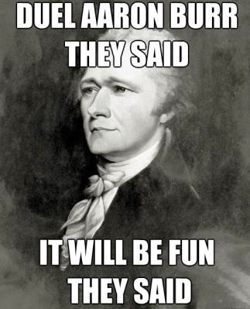
Who won the battle of political ideology: Jefferson/Madison or Marshall? Explain your reasoning?
Effect
•
Cause and effect of the case of Marbury vs. Madison (1803)
- Cause

Federalists feared that the country was being debased by virtually every move that Jefferson made. A group of Federalists called the Essex Junto existed in Boston and loudly campaigned against the decline in public virtue they saw personified in Jefferson. Thomas Pickering, from Mass. Saw Jefferson as a Parisian revolutionary monster. A younger group of Federalists tried to improve the image of the party, although the federalist candidate for President, Charles Pinckney, received only 14 electoral votes in the 1804 election.

Aaron Burr, VP, did nothing meaningful for Jefferson due the fiasco that was the election of 1800. Some New England Federalists had spoken about leaving the Union and forming a Northern Confederacy. They tried to get Alexander Hamilton to join them, but he refused. They next approached Aaron Burr, who was trying to become Governor of NY since he saw no political future with Jefferson. Hamilton accused Burr of attempting to ruin the United States; hence Burr challenged Hamilton to a duel. Spoiler Alert!!! Hamilton is killed in the duel, Burr was indicted for murder.

From the Constitution:
Article III, section 3, of the Constitution provides that “Treason against the United States, shall consist only in levying War against them, or in adhering to their Enemies, giving them Aid and Comfort. No Person shall be convicted of Treason unless on the Testimony of two Witnesses to the same overt Act, or on Confession in open Court.”

- To what extent does the Burr controversy illustrate the impact of territorial expansion?

- using the above excerpt, explain why Burr was NOT guilty of treason in Marshall’s view.

- To what extent was Jefferson’s foreign policies similar to those of Washington? Explain:

- To what extent was Jefferson’s foreign policy successful in keeping the US neutral?

Beginning with the Jefferson Administration, the role of the Supreme Court changed. The Supreme Court decisions sought to assert federal power over state laws and the primacy of the judiciary in determining the meaning of the Constitution.

Important Court Cases (year) | Main cause explained | Ruled in favor of/ and why | What precedent it established | How it increased govt power?
Marbury v Madison
Fletcher v. Peck
McCulloch v. Maryland
Dartmouth College v. Woodward
Gibbons v. Ogden
Cherokee Nation
v. Georgia

Between Washington and Jefferson, the new country continued to grow and develop – politically, economically and socially. List 8 ways the new republic grew and changed:

1.
2.
3.
4.
5.
6.
7.
8.

Change can be good, but there can be conflict also. What are 4 ways the new republic saw an increase in conflict:
1.
2.
3.
4

Jefferson’s foreign policy did not go according to plan. He was forced to face the growing problems in Europe and Northern Africa.

Who were the Barbary Pirates?

What did they do? How did previous administrations handle this problem? What did Jefferson do?

Explain the cause and effect of the Chesapeake – Leopard Affair: Causes:

Effects:

HIPP TIME!!
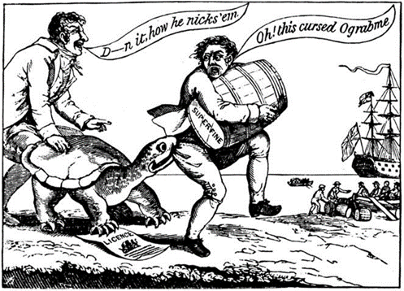
I P
P
H:

To what extent was Jefferson’s foreign policy successful in keeping the United States neural? Explain in 3-5 sentences:
Look on page 137: What does the graph show? Does this graph support your answer above? Explain in 3 sentences.

James Madison’s Presidency
Years elected: Years served: Political Party:
His time as President is known as: because:

European wars spills over to America – Again! The Napoleonic wars of Europe began in 1802 and lasted until 1815. Most Americans viewed its role in these war as neutral – yet still had to deal with conflicts from both France and England.
According to the terms of the Continental System - American ships that traded with Britain were sometimes stopped and
seized. British ships seized other nations ships if they were caught trading with the French West Indies. The practice of IMPRESSMENT began to get Americans angry.

- What is Impressment?

Jefferson thought that economic pressure would cause the British and French to respect American ships, but it didn’t work.

Which part of the country began to fill the effects of the Embargo first? Why?

Enter Madison: When James Madison took office, he replaced the hated embargo act with the Non-Intercourse Act, which

. Eventually this act was also
replaced with Macon’s Bill #2 which
In APUSH classes, we rarely have time to really go deep into the wars, therefore the rule of thumb is to always know the cause and effects:

War of 1812: | It was always about RESPECT!
CAUSES |  | EFFECTS
1. |  | 1.
2. |  | 2.
3. |  | 3.
4. |  | 4.
5. |  | 5.

- Was Madison’s foreign policy more successful than Jefferson’s? Why or why not?

- Explain the British and French Viewpoint that neutrality doesn’t necessarily guarantee freedom of the seas: British:

French:

- Of the main causes of the War of 1812, which is the most significant? Explain your answer in a minimum of 5 sentences.

- Was the United States justified in declaring war against Great Britain? Why or why not?
The struggle to create an independent global presence placed US policymakers in a difficult position. They sought to dominate North America and promote its trade around the world. This goal was to establish a sense of NATIONALISM; but all it really did was firmly establish SECTIONALISM.

Look at the map on page 139. What does it reveal about who supported the war? Explain in 3 sentences:

Who opposed the war?

Which point of opposition to ‘Mr. Madison’s War” was the most significant to growing sectionalism?

TIMELINE OF THE WAR OF 1812
YEAR | KEY EVENTS EXPLAINED
1812
1813
1814
1815

Okay, stupid question but I have to ask: Who won the War? Explain your answer. Give three specific pieces of HISTORICAL evidence that support your view:
1.

2.

3.

What were the condition outlined in the Treaty of Ghent? What changed? What didn’t change?

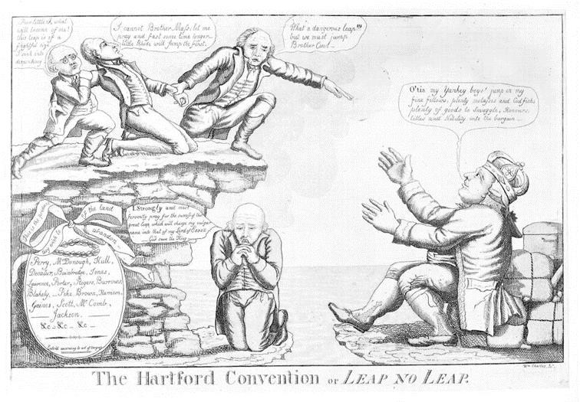
HIPP-ish Time – yes again!

What was the Hartford Convention?
Who attended and why?
What was their purpose? What happened? Why?
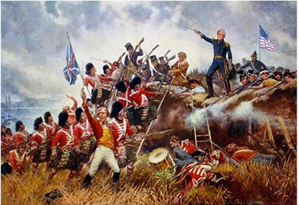

Who is in the picture?

What battle?

Why was this significant?

While Americans celebrated their nation’s progress toward a unified new national culture that blended Old World forms with New World ideas, various groups of the nation’s inhabitants developed distinctive cultures of their own.  What was the Era of Good Feelings?  To what extent did America begin to develop a sense of Cultural Nationalism? Give 3 pieces of historical evidence to support your answer :  Economic polices helped to foster a sense of Nationalism: Explain each of the following:  Tariff of 1816  Henry Clay’s American System The Panic of 1819  The nation’s transformation to a more participatory democracy was accompanied by continued debates over federal power, the relationship between the federal government and the states, the authority of different branches of the federal government, and the rights and responsibilities of individual citizens.  Political Changes  - Changes in the Democratic-Republican Party | In your opinion, to what extent was this era “good?”  President James Monroe was the last of the Virginia Dynasty. List the other presidents who fall into this group:  How did the Tariff of 1816 differ from the tariff in Hamilton’s Economic Plan in the early 1790’s?  Who was Henry Clay? Was he (and his plan) more Hamiltonian or Jeffersonian? Explain your answer:  What caused the Panic of 1819? To what extent did it impact American voters?
Even though the nation was under a single political system, division began to emerge resulting in the eventual formation of new parties. Compare the causes of these divisions to the causes of the Hamilton/Jefferson division leading to the first two party system in the 1790’s?

Causes:

To what extent were these forces similar?

How were they different?

PRESIDENTIAL REVIEW TIME

President | Year Elected | Year Served | Party | 2 Foreign acts | 2 domestic acts
1
2
3
4
5
6
7

The American acquisition of lands in the West gave the rise to a contest over extension of slavery into the western territories as well as a series of attempts at national compromise. Whites living in the frontier tended to champion expansion efforts while resistance by American Indians led to a sequence of wars and federal efforts to control the Native American Indian population.

Nationalism vs. Sectionalism
Love is worth fighting for . . .” by Kris Kristofferson

In one way or another, the needs of the nation or the needs of a region contributed to nationalism (love of country) or sectionalism (love of region). Numerous events in our early history are often classified as such. The important thing to remember is that sectional priorities can shape, good or bad, the policies of the national government.

For instance, Henry Clay believed that if all sections of the country helped each other out, all would benefit. He called it The American System. Easterners wanted high tariffs on imports. This would raise tax revenue for the U.S., but also it would encourage Americans to buy “American.” Let’s take a look:

Southerners and western farmers, on the other hand, wanted things like bridges and roads built. These things, known as internal improvements, would allow crops get to market quicker and cheaper.
This is an example of nationalism because each region helped the other out in the spirit of cooperation, and to get what it wanted! Without the help of the other, none of these things would have occurred!

Expansion . . . American Style!
During the early to mid-nineteenth century, Americans believed in MANIFEST DESTINY, a fancy term for expansionism. Simply stated, Americans believed the United States must own all the land to the Pacific Ocean. The reasons for expansion are many. First, Americans were land-hungry. Second, democratically minded people believed that growth meant freedom, and finally, there were people who believed that the United States must grow in order to reveal its “greatness.” As we already know, once the United States of America gained freedom from England in
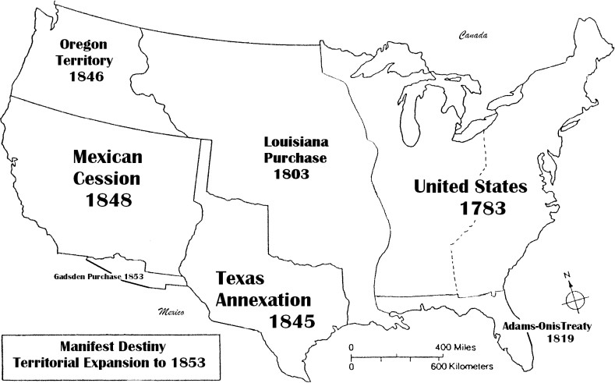
1783, the Mississippi River was the western boundary. Also, the purchase of the Louisiana Territory in 1803 doubled the size of the United States. The Lewis and Clark expedition exposed the many natural treasures which created a curiosity and drive amongst people to move west.
Sometimes land just happens! In the Adams-Onis Treaty of 1819, Spain gives most of Florida to the United States. In 1821, newly independent Mexico invites American settlers to live in Texas. In the 1830s, Mexicans and Americans clash due to cultural and land conflicts. In 1836, Texans rebel against the Mexican government. Americans are at war (War for Texas Independence) and although the massacre at the Alamo (Spanish mission/fortress) was devastating
and a low point for Texans, they eventually gain their independence from Mexico in 1836.
Many Americans want Texas annexed by the United States. In 1845, President Polk and the Congress annexed Texas. Mexico is angry when the U.S. claims the Rio Grande River as the southern boundary to the US.
1846: Boundary dispute with Mexico leads to war: Mexico versus U.S.A.
1848: Mexico surrenders and gives up claim to California, New Mexico and Utah territories. New concerns about slavery will emerge due to the Mexican Cession lands.
In 1846, there is also a conflicting claim for the Pacific Northwest with Great Britain.
The US threatens to go to war with the “54, 40 or fight!” slogan. In the end, President Polk agrees to the 49th parallel and the Oregon Territory is ours!
Finally, in 1853, the United States buys a small bit of property from the Mexican government known as the Gadsden Purchase. This land will complete American’s needs for land, or will it?

Using this reading and your textbook, complete the following. Which lands were . . .
BOUGHT? | ANNEXED? | WON IN WAR? | NEGOTIATED THROUGH TREATY?

Using your map in this reading, determine whether the statement is true or false:
1. Texas was part of the Louisiana Territory.
2. The Mexican Cession was added to the United States in 1803.
3. U.S.A. and Great Britain went to war over the Oregon Territory.

Manifest Destiny and Compromise
“Compromise makes a good umbrella, but a poor roof;”
-JR Lowell

REVIEW: During the early to mid-19th century, Americans believed in MANIFEST DESTINY, a fancy term for
ism. In this phase of expansion, we annex (1845), we bargain for Florida ( ) and the
(1846), we must fight a war for the land called the
(1848), and we buy land 1803’s and the 1853
. In the end, our destiny was fulfilled!

Directions:
Blue = Free states Red = slave holding states Brown = US territory Yellow = foreign owned

USA: 1783 USA: 1803

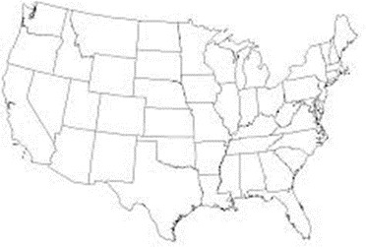

USA: 1820

Based off these 3 maps:

- What changed?

- How many states supported slavery?

- How many states did not openly support slavery?

- What did the Missouri Compromise do? Did it help? Give 2 historical reasons to support your position.

Life in the 1800s
Different parts of our nation have different needs and goals. Remember! Northern businesses involved manufacturing and shipping, while the south and west regions were mainly agricultural. The
Industrial Revolution changed lives in all regions of the U.S. because inventions required less human labor and more machine power.

During the early years, the need for labor was great. The south aka “the Cotton Kingdom,” used the plantation system. Slaves were essential in this system. In the north, the factory system dominated the region. By exploiting children as young as seven and young unmarried girls, factory owners made a higher profit. The work was hard and the pay very low.

- Compare/contrast the Plantation System and the Factory System:
 | Plantation system | Factory System | Why the difference/similarity
Economic
Political
Social

Inventions and inventors during this era played a huge part in the development of the United States. Eli Whitney made cotton profitable with his “cotton gin.” In 1834, Cyrus McCormick invented the mechanical reaper which made crops easy to produce. These inventions encouraged Americans to move west and with this movement, regional conflict
occurred.

  - Other inventions that came about and how they changed the lives of Americans:
1.

2.

3.

4.

5.

Outline roads in green and canals in blue

Some inventions tried to tie the nation together, to make it seem smaller than it was. Robert Fulton’s steamship reduced the time it took to transport goods and people. The Erie Canal (1825), located in the middle of New York, linked the Great Lakes to the rest of the world by providing a quick route to the Atlantic Ocean. Roads, too, started to appear in the early 1800s. The Cumberland Road and the Wilderness Road provided transportation networks for farmers in the mid-west.
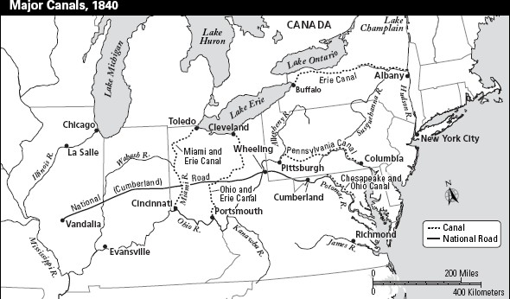

Let’s review some basic concepts, using the table:
Title of the chart is
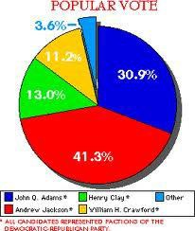
Election o 1824 – the “corrupt bargain”
Political party Presidential Nom. # %
Democratic-Repub. Andrew Jackson 99 | 37.9
Democratic-Repub. John Q. Adams | 84 | 32.2
Democratic-Repub. William Crawford 41 | 15.7
Democratic-Repub. Henry Clay | 37 | 14.2

Amendment 12, United States Constitution (1800)
“if no person have such a majority (of electoral votes), then from the persons having the highest numbers not exceeding three on the list of those voted for as President, the House of Representatives shall choose immediately by ballot the President …”

Examine the electoral results from 1824 and the excerpt from the 12th Amendment.
- Why did Jackson not become President-elect after receiving the most electoral vote?

- How was the election of 1824 settled?

Andrew Jackson: Common Man’s President

Andrew Jackson’s election win in 1829 marked a big change in American politics. He was the Common Man’s President because he was born in poverty and moved-up in society. He is criticized for employing the spoils system. This meant that he rewarded political supporters and friends with jobs in government, even if they were not qualified for the job.

Another issue which happened during Jackson’s time was the “Native-American Question”

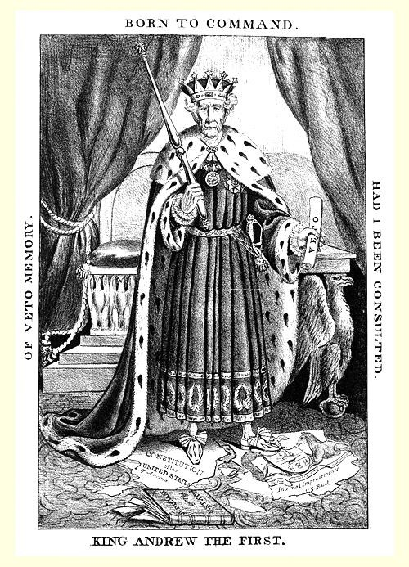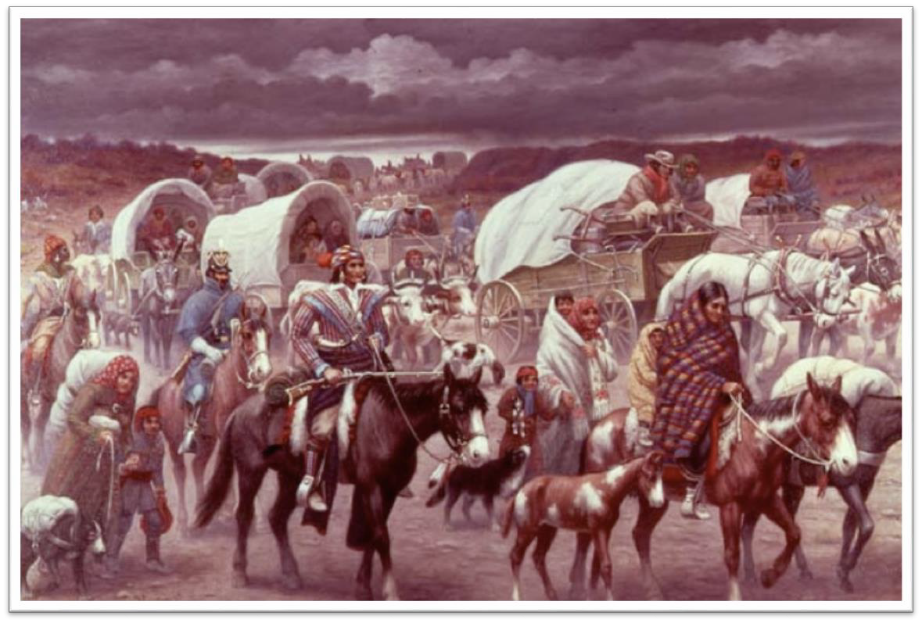
H
I
P
P

H

I P P
Reform and Romanticism
Change America: change it for the better!

The years between 1830 and 1850 were an age of reform. Machines brought changes, some good and some bad. Americans were proud of their country and any flaws were annoying! Reformers want change: change for the better!

Religious Reform: The Second Great Awakening
A new religious excitement swept through the United States at this time. People were joining different types of churches: Presbyterian, Methodist, and Baptist. Americans joined new religious groups that wanted to improve the condition of mankind. The Mormons and Adventists are examples of this. Bitterly despised for their beliefs, Mormons move to Utah Territory to avoid religious conflict.
Also, Ideal Communities tried to reform and change the world; among these groups, the Shakers, New Harmony, Oneida, and Brook Farm lived together in small groups in order to worship freely and to help mankind. Shakers, for example, adopted children from overcrowded orphanages as they believed that they were all “brothers and sisters” in Christ and that helping children is the godly thing to do. This era helped promote our modern understanding of religious tolerance and diversity.

Temperance Movement
Many reformers blamed liquor for most of society’s problems. Backed by the religious movement, the “Anti- liquor Leaguers” wanted people to stop drinking that “evil demon rum!” This is the beginning of the push for outlawing alcohol in the United States.

Education Reform
It wasn’t easy to persuade Americans that each child deserved an opportunity to learn in school. Horace Mann convinced Americans that education was the key to a person’s success. Mann wanted to make education exciting. He helped set-up teaching colleges so that teachers would be trained. And while not perfect because slaves could not attend school and girls were discouraged to go to school, school enrollment increased. High school at the time was considered a luxury as many families depended on teenagers to help with family income. But this was a good first step, thanks, Mr.
Mann!

Noah Webster wrote a spelling book. He encouraged using “American spelling and usage,” rather than British English. The words, COLOR, not Colour, HONOR, not honour are examples of the changes.

Help for the Mentally Ill
Before the Reform Movement, people who suffered from mental illness were often sent to prison. Dorothea Dix changed the way Americans thought about mentally ill people. She established hospitals all along the eastern coast of North America. She sought compassion for those who could not help themselves.

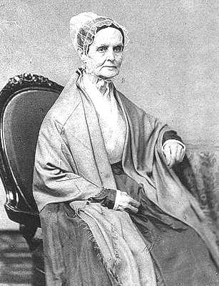
Women’s Rights
Two women of the Reform Era are credited for promoting equality among men and women: Elizabeth Cady Stanton and Lucretia Mott. In 1848, brave women and men gathered at Seneca Falls, New York and declared the “All men AND WOMEN are equal!” This “Seneca Falls Declaration” was considered radical for the time. The group also discussed women’s right to vote. Sadly, both women died before the 19th Amendment was passed, but the Seneca Falls Convention and the women’s contributions to it are considered to be the first step in women’s suffrage.

Lucretia Mott

Abolitionism
Have you ever cared for something so strongly that you ignored society’s standards? Have you ever been publicly humiliated for your beliefs? Abolitionists were people who wanted slavery to end immediately. This was an unpopular belief at the time, but abolitionists didn’t care. Slavery was wrong and had to end! Quakers were the first group to speak out against slavery. The Quaker Grimke sisters were southern women who totally rejected their home (Charleston), family (father was a slaveholder), and way of life (wealth and position) in order to see slavery end. William Lloyd Garrison published a newspaper called The Liberator. He was a radical, in-your-face kind of person and when it came to ending slavery he would not be silenced. His famous words are, “I am as harsh as truth . . . I will not retreat a single inch, and I will be heard!” The abolition movement was influenced by the religious movement of the time.
There were African American abolitionists who risked their own well-being to expose the evils of slavery.
Frederick Douglass was a freed slave and a powerful speaker who convinced many northern citizens that slavery was immoral. Harriet Tubman risked her own life as a conductor on the Underground Railroad; at one time she had a
$40,000.00 bounty placed on her. Sojourner Truth fought for both abolition and women’s rights. All abolitionists were considered radical for the day because they challenged the status quo.

Review questions for you to answer

- He urged American spelling over British English
- This group fled to Utah to escape persecution.
- Mott and Stanton led which movement?
- He was the publisher of The Liberator
- This declared “all men and women are equal”
- Earliest group to speak out against slavery
- He was the “Father of the American School System”
- Southern Quakers who were abolitionists

Using the code below, decide the area of reform each sentence is referring to, it may have more than one code.

A. Education | D. Improving Society
B. Women’s Rights | E. Temperance Movement
C. Ideal Communities | F. Abolitionism

The insane were treated like criminals.
A democracy needs people that can read and write.
“Demon rum” is evil and must be prohibited.
S.A.D.D is similar to this movement.
Lucretia Mott and Elizabeth Stanton are its leaders
Slavery is a moral wrong and goes against ideas of democracy.
Noah Webster wrote the first American spelling dictionary.
Teacher colleges were set-up.
By 1860, 90% of all free adults could read.
Helping orphans live a better life.

Which of the following movements were, in part, motivated by religious ideas: answer yes or no.

EDUCATION Y N | ABOLITION Y N
WOMEN’S RIGHTS Y N | IDEAL COMMUNITIES Y N
TEMPERANCE Y N | HELP FOR MENTALLY ILL Y N

Reform and Romanticism
Not smooch love, but love of country!

Recently, we discussed how the early 19th century was a period of reform. In addition to this, American writers were producing some of the most influential writing of our history. We are required to know these writers and their importance. We call this literary period the Romantic Era/Naturalism. It contributes to nationalism.

Highlights in American Writing

Wrote Moby-Dick, or The Whale, a powerful story of the struggle between good and evil.

Was fascinated by the Puritan past of New England. In 1850, he wrote The Scarlet Letter, in which he urged the reader to condemn not sin, but those who judge the sinner.

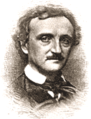
Told American writers they should write about the American experience, not the European one. Poe’s work is still enjoyed by many to this day. Stories like the Tell Tale Heart and The Pit and the Pendulum and poems like The Raven examine the darker side of life.

EA Poe

Is very famous for his stories which are set in the Hudson River Valley and the Catskill Mountains of New York. Rip Van Winkle and The Legend of Sleepy Hollow are two of his most famous works.

Romanticized the American frontier during the French and Indian War. His novel, The Last of the Mohicans is still widely read today.

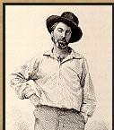
Is an American poet who sought to bring our nation together as one. He deeply believed in democracy and the ability of Americans to make a better life for themselves. He wrote Leaves of Grass.

All of these writers contributed to the era. They were promoting American beliefs and feelings; namely, love of country. This is nationalism, pure and simple.

And then there’s the Transcendentalists . . .

Transcendentalism is a philosophy of life in that people should free themselves from ignorance and prejudice, to think on their own, and to respect the rights of others. Self-reliance and faith in the individual is most important in this belief. Additionally, transcendentalists urged people to disobey unjust laws, even at the risk of going to jail!
Wrote the famous essay, “Civil Disobedience” that said if a person’s conscience told them a law was unjust, the person MUST protest. Was also part of the movement. Democracy is the key to transcendentalism, why?

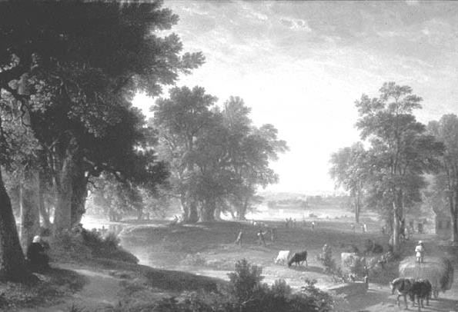
Art during the Romantic Period
Before the 1800s, art was usually imported from Europe, in fact, even local artists painted scenes from Europe! But that began to change in the early 1800s. American artists expressed pride through painting scenes of the American landscape. One group which is most notable is the Hudson River School. Artists from the school painted beautiful scenes from the Hudson River Valley as well as the Catskill Mountains.
- What did the Hudson River School promote?

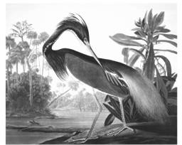
Another American artist, James Audubon, illustrated Birds of America. This led to the formation of a group which protected birds. Today, the Audubon Society is a nature conservation group.

Audubon’s Louisiana Heron

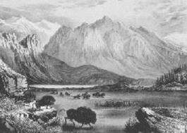
Currier and Ives were artists of the era which made hand-colored prints. These prints, which showed people and nature together, are still quite popular today.

Neoclassical Architecture

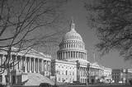
Currier and Ives Rocky Mountains

Inspired by the classical architecture of ancient Greece and Rome, Americans loved to connect Grecian democracy with American democracy. A Neoclassical building may have features such as domed roof, symmetry, tall columns, and triangles, known as pediments.

The US Capitol

TIME TO REVIEW, again

Political Changes
Compare and Contrast Jeffersonian Democracy with Jacksonian Democracy: Similarities:

Differences:

What were the important decisions made by the following court cases?
- Worchester vs. Georgia
- Cherokee nation vs. Georgia
- McCullough vs. Maryland
- Gibbons vs. Ogden
- Fletcher vs. Peck
- Charles River Bridge vs. Warren Bridge What is the theory of Nullification?

Political party | Date started | Key beliefs | Leaders
Democrat
Whigs
Know-Nothings
Republicans
Democrat-republican
Whigs
Free- Soil

Social Changes
- How did the lives of Women change during this time period?

- How did the lives of Blacks change during this time period?

- How did the lives of Indians change during this time period?

- How did Religion change during the time period

- What changes in transportation occurred

National Changes

- What is Nationalism:

- Name 3 examples of nationalism that occurred during this time period

- What is Sectionalism

- Name 3 examples of sectionalism that occurred during this time period

Economic Changes

Date | Event | Causes | Effects
 | Panic 1819
 | Panic of 1837
 | Death of 2nd National Bank
 | Independent Treasury Act

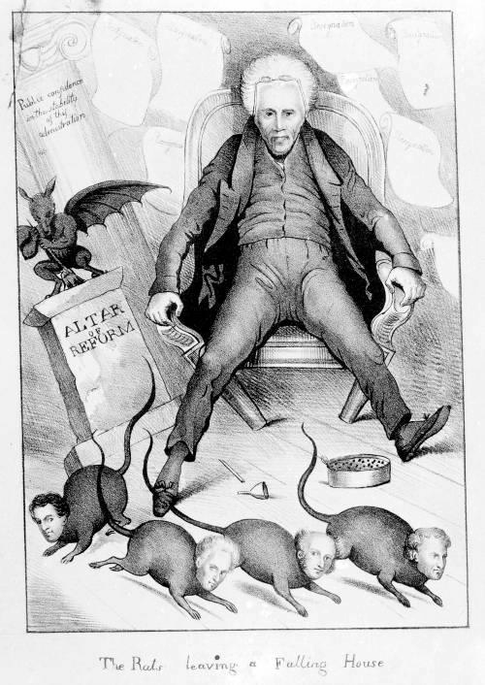
Identify the main message behind each cartoon and perform HIPPO for each one

Title – The Rats leaving a Falling House
Pillar – Altar of Reform
Column – Public confidence in the stability of this administration

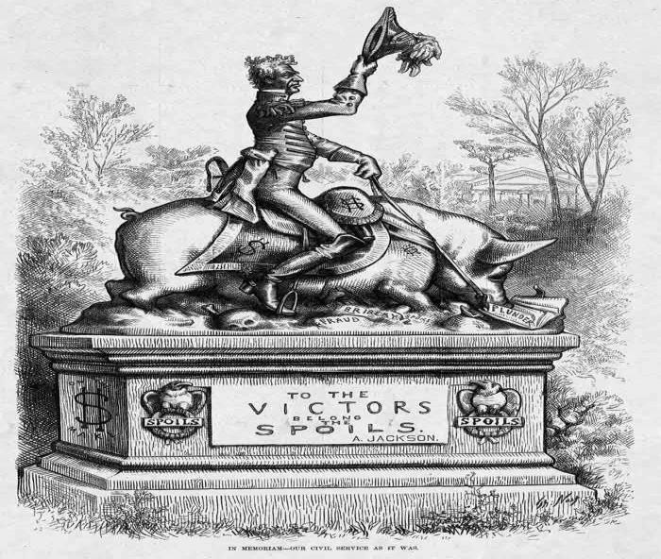

Title – In Memoriam – Our Civil Service as it war
Under the hog – Fraud; bribery; spoils; plunder
On the Base – To the Victors Belong the Spoils – Andrew Jackson

