DOCUMENT-BASED QUESTION

This question is based on the accompanying documents. The question is designed to test your ability to work with historical documents. Some of these documents have been edited for the purposes of this question. As you analyze the documents, take into account the source of each document and any point of view that may be presented in the document. Keep in mind that the language used in a document may reflect the historical context of the time in which it was written.

Historical Context: Causes of the Civil War

Between 1800 and 1860, a number of economic, social, and political factors contributed to the development of tension between states. Specifically, tension developed around issues of how to best expand the US economy, the extension of slavery into the territories, and relationship between the states and the federal government. Debates and differences in opinion over these, and other matters of national importance, eventually led to the United States civil war.

Task:
UNITED STATES HISTORY SECTION II Total Time—1 hour and 40 minutes
Question 1 (Document-Based Question)
Suggested reading and writing time: 1 hour It is suggested that you spend 15 minutes reading the documents and 45 minutes writing your response.
Note: You may begin writing your response before the reading period is over.

Directions:
Question 1 is based on the accompanying documents.
The documents have been edited for the purpose of this exercise. In your response you should do the following.
- Respond to the prompt with a historically defensible thesis or claim that establishes a line of reasoning.
- Describe a broader historical context relevant to the prompt.
- Support an argument in response to the prompt using at least six documents.
- Use at least one additional piece of specific historical evidence (beyond that found in the documents) relevant to an argument about the prompt.
- For at least three documents, explain how or why the document’s point of view, purpose, historical situation, and/or audience is relevant to an argument.
- Use evidence to corroborate, qualify, or modify an argument that addresses the prompt

Prompt: Evaluate to what extent sectionalism between the North and South led to the Civil War.

Step 1: Understand the prompt
What is the prompt asking you to do?

What historical thinking skill is being questioned?

Step 2: Brainstorm what you already know
What do you already know?

Step 3: Build a preliminary argument
How would you answer this question - Did sectionalism cause the Civil War? If so, how? If not, then what did? (use your outside evidence to help you answer this question)

Step 4: Analyze Documents

Document 1
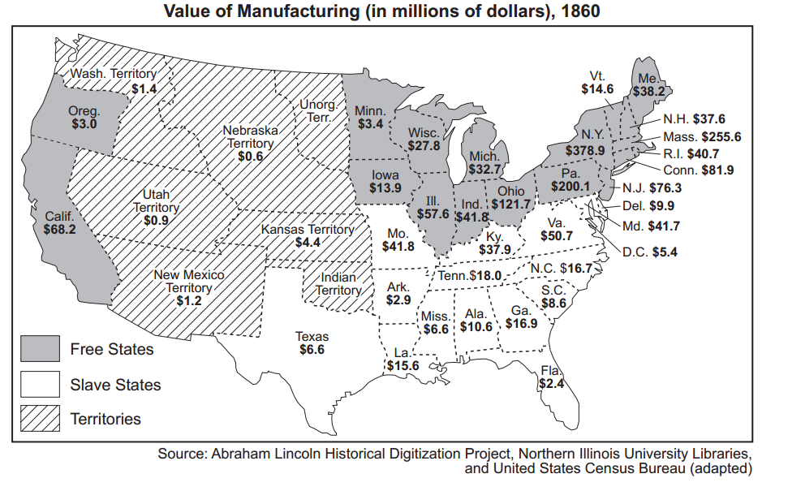
Content | Historical Context
Audience | Point of View (author)
Purpose | Why is this important?
Document 2 - The American Anti-Slavery society was formed in 1833 in Philadelphia. Nearly all of it’s members were from New England states. Agents of the American Anti-Slavery Society traveled throughout the United States to urge the abolition of slavery.

Dear Sir - You have been appointed an Agent of the American Anti-Slavery Society…

...Our object is, the overthrow of American slavery, the most atrocious and oppressive system of bondage that has ever existed in any country. We expect to accomplish this, mainly by showing to the public slavery’s true character and legitimate fruits [real effects] contrariety [opposition] to the first American principles of religion, morals, and humanity, and its special inconsistency with our American democratic aims, as a free, humane, and enlightened people. IN this way, by the force of truth, we expect to correct the common errors that prevail respecting slavery, and to produce a just public sentiment, which shall appeal both to the conscience and love of character, of our slave-holding fellow-citizens, and convince them that both their duty and their welfare require the immediate abolition of slavery… Slavery is un-American.
Source: Letters of Theodore Dwight Weld, Angelina Grimke Weld and Sarah Grimke, 1822 - 1844 American Historical Association 1934

Content | Historical Context
Audience | Point of View (author)
Purpose | Why is this important?

Document 3 - Thomas R. Dew defends slavery in a debate in the Virginia Legislature.

According to the census of 1830, there were approximately 470,000 slaves in Virginia. The average value of each slave is about $200. Thus the total value of the slave population in Virginia in 1830 was $94,000,000. Allowing for the increase since, the present value of slaves in Virginia is about $100,000,000. The assessed value of all the houses and lands in the state amounts to $206,000,000. Do not these simple statistics speak volumes upon the subject? It is seriously recommended to the state of Virginia that she give up her slaves. In other words, Virginia is expected to sacrifice one-half of her total worth!

It is, in truth, the slave labor in Virginia which gives value to the soil and to her economy. Take this away and you ruin her. Remove the slave population from the State and it is absolutely safe to say that on the day this happens, Virginia will become a “waste howling wilderness.”
Source: Thomas R. Dew, Review of the Debate in the Virginia Legislature of 1831 and 1832, in The People Make a Nation, Allyn and Bacon, 1971

Content | Historical Context
Audience | Point of View (author)
Purpose | Why is this important?
Document 4 - Following the Mexican-American War, there was much debate amongst Americans & Congressional leaders regarding whether or not Texas’s petition to join the United States should be ratified. Stephen C Phillips was a congressman from Massachusetts who strongly opposed the annexation of Texas. Below is an excerpt of a speech he gave on this debate.

The plot for the annexation of Texas…slowly developed the foul purpose in which it originated…from the outbreak of the insurrection in the department of Texas...every step that was taken to promote a revolution, and to establish temporarily a new government, was taken under the advice, and chiefly through the agency, of slave-holders belonging to the United States, who were intent upon defeating anti-slavery policies of the Mexican republic, and sought at the same time, through the accession of a vast slave-holding territory, to extend and perpetuate the power of the Slave states in this union. Texas should not be annexed, for it would unbalance our nation and our government...
Source: Excerpts from the Address on the Annexation of Texas, and the aspect of Slavery in the United States by Stephen Phillips

Content | Historical Context
Audience | Point of View (author)
Purpose | Why is this important?

Document 5 - On January 29, 1850, Senator Henry Clay proposed a series of resolutions to settle “...all questions in controversy between the free states and slave states....” The list below contains excerpts from Clay’s speech.
Selected Proposals for the Compromise of 1850
- That California ought to be admitted into the Union without restriction as to the inclusion or exclusion of slavery.
- That as slavery does not exist by law, and is not likely to be introduced into any of the territory acquired by the United States from the Republic of Mexico, it is not in the interest of Congress to pass a law either establishing or prohibiting it in the land acquired from Mexico.…
- That it is not wise to abolish slavery in the District of Columbia while slavery continues to exist in Maryland without the consent of that state, the consent of the people of the District, and without just payment to the owners of slaves within the District.
- That, however, it is wise to prohibit in the District of Columbia, the bringing-in of slaves from other states either to be used in the District or to be sold there for use in other states.
- That stronger provision ought to be made by law for the capture and return of slaves who may have escaped into any other state or territory in the Union.
- That Congress has no power to prohibit or prevent the trading of slaves between States. This depends completely on the laws of each individual state.
Source: Compromise of 1850
Content | Historical Context
Audience | Point of View (author)
Purpose | Why is this important?
Document 6 - Confederate General John B. Gordon was a civilian-turned-soldier who became one of General Robert E. Lee’s most trusted commanders. Below is a excerpt of his memoirs from the Civil War.
“… The South maintained with the depth of religious conviction that the Union formed under
the Constitution was a Union of consent and not of force; that the original States were not the
creatures but the creators of the Union; that these States had gained their independence, their
freedom, and their sovereignty from the mother country, and had not surrendered these on
entering the Union; that by the express terms of the Constitution all rights and powers not
delegated were reserved to the States; and the South challenged the North to find one trace of
authority in that Constitution for invading and coercing a sovereign State.
The North, on the other hand, maintained with the utmost confidence in the correctness of her
position that the Union formed under the Constitution was intended to be perpetual; that
sovereignty was a unit and could not be divided; that whether or not there was any express power
granted in the Constitution for invading a State, the right of self-preservation was inherent in all
governments; that the life of the Union was essential to the life of liberty; or, in the words of
Webster, “liberty and union are one and inseparable…”
Source: John B Gordon, Reminiscences of the Civil War, Charles Scribner’s Sons, 1904
Content | Historical Context
Audience | Point of View (author)
Purpose | Why is this important?

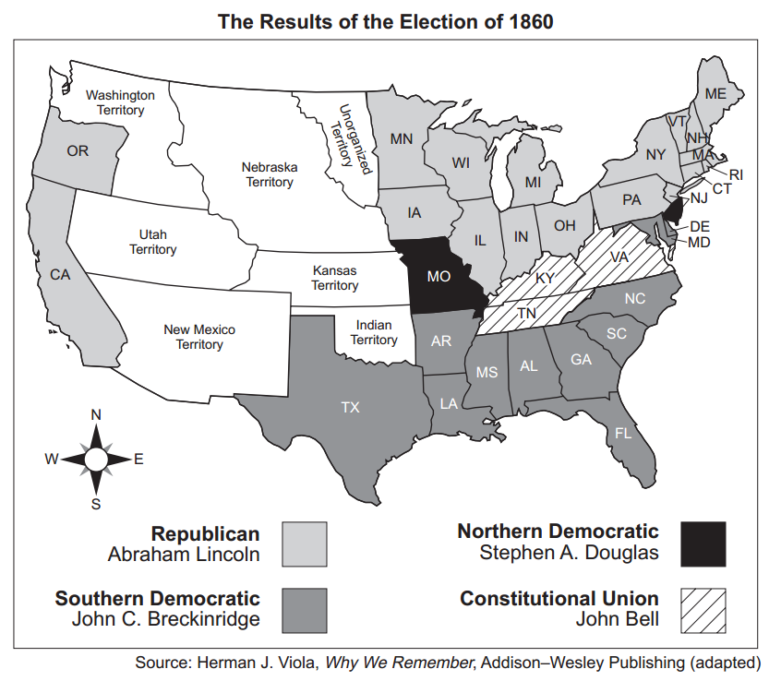
Document 7 -

Content | Historical Context
Audience | Point of View (author)
Purpose | Why is this important?

