THIS IS A TRADITIONAL & OPTIONAL ASSIGNMENT… IT MUST BE PRINTED AND COMPLETED IN INK!

Name:_______________________________________ Class Period:____ Due Date:___/____/____

Guided Reading & Analysis: Imperial Wars and Colonial Protest
Chapter 4- Imperial Wars and Colonial Protest, pp 68-84

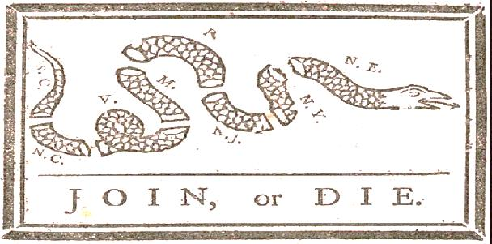
Reading Assignment:
Ch. 4 AMSCO or other resource for content corresponding to Period 3.

Purpose:
This guide is not only a place to record notes as you read, but also to provide a place and structure for
reflections and analysis using higher level thinking skills with new knowledge gained from the reading.

Basic Directions:
- Pre-Read: Read the prompts/questions within this guide before you read the chapter.
- Skim: Flip through the chapter and note the titles and subtitles. Look at images and their
read captions. Get a feel for the content you are about to read.
- Read/Analyze: Read the chapter. Remember, the goal is not to “fish” for a specific answer(s) to
reading guide questions, but to consider questions in order
to critically understand what you read!
- Write Write your notes and analysis in the spaces provided.
(Image Source: Benjamin Franklin, Pennsylvania Gazette, 1754, Public Domain This graphic was based on a common superstition that a severed snake could come back to life if its
sections were joined prior to sundown. Believe it or not! )

Key Concepts FOR PERIOD 3:
Key Concept 3.1: British attempts to assert tighter control over its North American colonies and the colonial resolve to pursue self-government led to a colonial independence movement and the Revolutionary War.
Key Concept 3.2: The American Revolution’s democratic and republican ideals inspired new experiments with different forms of government.
Key Concept 3.3: Migration within North America and competition over resources, boundaries, and trade intensified conflicts among peoples and nations.

Guided Reading, pp 68-77
As you read the chapter, jot down your notes in the middle column. Consider your notes to be elaborations on the Objectives and Main Ideas presented in the left column. When you finish the section, analyze what you read by answering the question in the right hand column.

- Overview and Alternate View p. 68

Key Concepts &  Main Ideas | Notes | Analysis
British imperial attempts to reassert control over its colonies and the colonial reaction to these attempts produced a new American republic, along with struggles over the new nation’s social, political, and economic identity. | 1763…End of French and Indian War led to…  1783…Articles of Confederation led to…  1789…new Constitution implemented…  1800…election of Thomas Jefferson illustrated…  Alternate View | List 3 reasons why the end of French and Indian War was an important turning point in U.S. history.  1.  2.  3.  Besides the beginning and the end of this war, what else marks an important turning point to nationhood?
Are you using ink? Remember… no pencil!
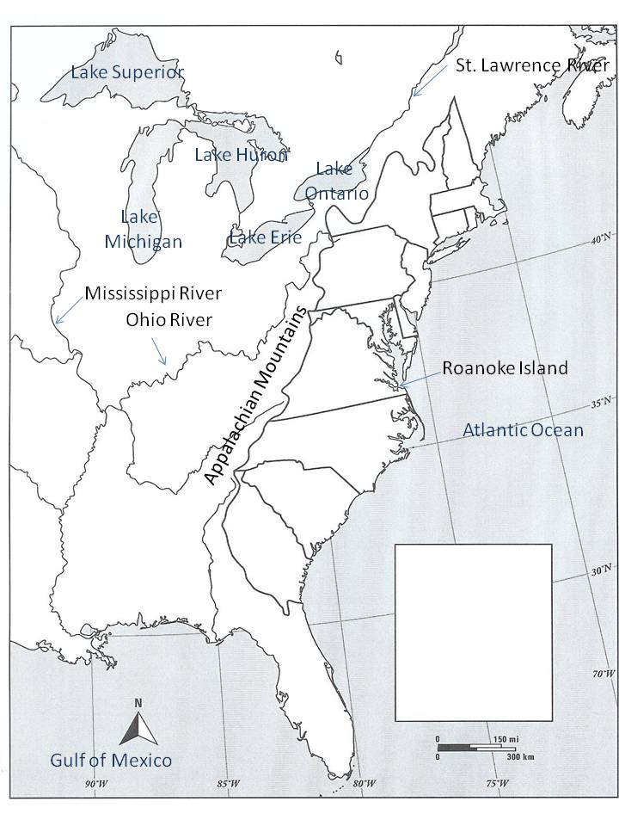
Map Break! Thirteen Colonies 1754
Caption:
Label colonies and highlight them one color.
Label French territory and highlight them a second color.
Then label and highlight British territory a third color.
Then label and highlight Spanish territory a fourth color.
Create a key.
Write a caption summarizing the significance of territory in 1754 to the European powers and the colonists.
13 colonies

Other British territory

French territory

Spanish territory

- Empires at War, pp 69-72

Key Concepts & Main Ideas | Notes | Analysis
Britain’s victory over France in the imperial struggle for North America led to new conflicts among the British government, the North American colonists, and American Indians, culminating in the creation of a new nation, the United States. | Empires at War…  The First Three Wars…  The Seven Years’ War (French and Indian War)…  Beginning of the War…  The Albany Plan of Union…  British Victory…  Immediate Effects of the War…  The British View…  The Colonial View… | What was the chief reason for colonial discontent?  List three major ways England’s war for empire impacted the colonies in North America.  1.  2.  3.  List three reasons the Albany Plan, aka “Join or Die,” failed.  1.  2.  3.  What was the most significant impact of the Treaty of Paris, 1763 (aka the Peace of Paris)? Explain your reasoning.  Compare the British View to the Colonial View and explain why these opposing views are significant to the development of the United States.

- Reorganization of the British Empire, pp 71-72

Key Concepts & Main Ideas | Notes | Analysis
After the British defeat of the French, white–Indian conflicts continued to erupt as native groups sought both  to continue trading with Europeans and to resist the encroachment of British colonists on traditional tribal lands. | Reorganization of the British Empire…  Pontiac’s Rebellion…  Proclamation of 1763… | Defend or refute the following statement:  1763 was an important watershed year.  List three pieces of evidence to support your view:  1.  2.  3.  Name one piece of evidence to support the opposing view:

Map Break! The 13 Colonies 1763
The map below (captured from Wikipedia) shows North American territorial gains of Spain in 1762 and Britain in 1763.
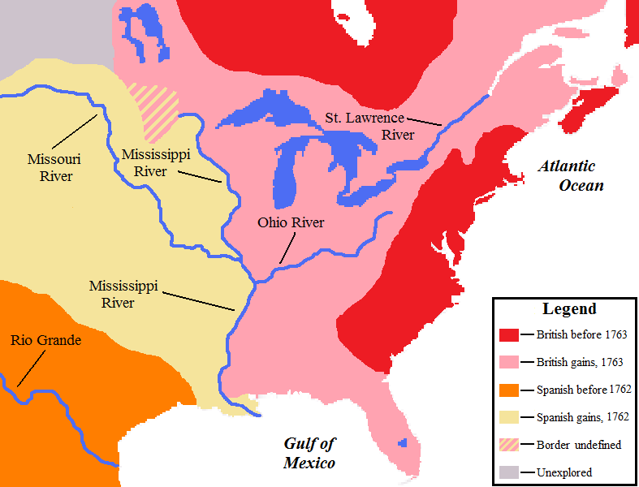
Explain the significance of the territorial changes from 1754 to 1763.

Using a highlighter, trace the location of the Proclamation Line of 1763.

What was the purpose of this line?

If the United States bought Louisiana from France in 1803, why does this1763 map show Louisiana as Spanish territory?

- British Actions and Colonial Reactions, pp 72-73

Key Concepts & Main Ideas | Notes | Analysis
During and after the imperial struggles of the mid-18th century, new pressures began to unite the British colonies against perceived and real constraints on their economic activities and political rights, sparking a colonial independence movement and war with Britain. | Proclamation of 1763…  New Revenues and Regulations…  Sugar Act (1764)…  Quartering Act (1765)…  Stamp Act (1765)…  Declaratory Act (1776)… | Identify the major causes and effects of the Stamp Act controversy.  Caused by:  Effects of:  What was the most significant cause of the controversy?  What was the most significant effect of the controversy?  The main source of resentment among colonists was:

- Second Phase of the Crisis, pp 73-74

Key Concepts & Main Ideas | Notes | Analysis
During and after the imperial struggles of the mid-18th century, new pressures began to unite the British colonies against perceived and real constraints on their economic activities and political rights, sparking a colonial independence movement and war with Britain.  The resulting independence movement was fueled by established colonial elites, as well as by grassroots movements that included newly mobilized laborers, artisans, and women, and rested on arguments over the rights of British subjects, the rights of the individual, and the ideas of the Enlightenment. | The Townshend Acts…  Continued on next page…  Repeal of the Townshend Acts…  Boston Massacre… | Explain the limitations of the repeal [of the Townshend Acts] in restoring positive relations between England and its ‘13 colonies’ in North America.  Of the following, whose contribution was most significant to the emerging American identity?  Charles Townshend, John Dickenson, James Otis, Samuel Adams, Lord North, Crispus Attucks  Defend your answer with specific evidence.  1.  2.  3.

- Renewal of the Conflict, pp 74-75

Key Concepts & Main Ideas | Notes | Analysis
Great Britain’s massive debt from the Seven Years’ War resulted in renewed efforts to consolidate imperial control over North American markets, taxes, and political institutions — actions that were supported by some colonists but resisted by others. | Renewal of the Conflict…  The Gaspee…  Boston Tea Party… | Explain how Committees of Correspondence and intercolonial committees sharpened the divisions between Britain and the colonies in the early 1770’s.  In what way does the Gaspee incident illustrate the overall turning point of 1763?  Were the Sons of Liberty justified in the Boston Tea Party? Defend your answer with three pieces of evidence.  1.  2.  3.

- Intolerable Acts and the Philosophical Foundations of the American Revolution, pp 75-77

Key Concepts & Main Ideas | Notes | Analysis
Great Britain’s massive debt from the Seven Years’ War resulted in renewed efforts to consolidate imperial control over North American markets, taxes, and political institutions — actions that were supported by some colonists but resisted by others.  The resulting independence movement was fueled by established colonial elites, as well as by grassroots movements that included newly mobilized laborers, artisans, and women, and rested on arguments over the rights of British subjects, the rights of the individual, and the ideas of the Enlightenment. | Intolerable Acts…  The Coercive Acts (1774)…  Quebec Act (1774)…  Philosophical Foundations of the American Revolution…  Enlightenment Ideas… | Explain how the Coercive Acts (Intolerable Acts) were both an effect of colonial actions and a cause of colonial action.  Explain the role of religion in colonial resistance to the new imperial policies of 1774.  Review the Enlightenment ideas located on the last page of your Period 2 Term Review, “Part 4 Looking Ahead.” List the most three most significant ideas that influenced our founding fathers as they resisted new imperial policies.  1.  2.  3.

Section 2: HIPP+
Historical Context:

Intended Audience:

Author’s Purpose:

Author’s Point of View:

+Other Context (Similar in Kind, In a Different Time)

If at length it becomes undoubted that an inveterate resolution is formed to annihilate the liberties of the governed, the English history affords frequent examples of resistance by force. What particular circumstances will in any future case justify such resistance can never be ascertained till they happen. Perhaps it may be allowable to say generally, that it never can be justifiable until the people are fully convinced that any further submission will be destructive to their happiness.

Source: Letter III, Letters From a Farmer in Pennsylvania, John Dickenson, 1767, Public Domain

Reading Guide written by Rebecca Richardson, Allen High School
Sources include but are not limited to: 2015 edition of AMSCO’s United States History Preparing for the Advanced Placement Examination, Wikipedia.org,
College Board Advanced Placement United States History Framework 2012 and 2015 versions, writing strategies developed by Mr. John P. Irish, Carroll High School, 12th edition of American Pageant,
other sources as cited in document, and other sources as cited in document and collected/adapted over 20 years of teaching and collaborating..

