ASSIGNMENT: MONUMENT ACTIVITY

Essential Question:
How have debates over economic values and the role of government in the U.S. economy affected politics, society, the economy, and the environment?

Directions:
Welcome to the United States Government. As a rising star in the Congress, you have been assigned to a Congressional Commission to examine the achievements and crimes of major industrialists. Your commission is to recommend whether there should be a monument on the Washington Mall to the “Great Industrialist” or the “Common Laborer.” Being the conscientious over-achiever that you are, you made sure to research all aspects of this decision—even interviewing people from all over America to make sure you made an informed decision.

On the following pages, under each of the following topic statements, list facts that support the thesis. Remember to only include information which directly supports your thesis. Also, list information gained from documents, then using those pieces of evidence, provide analysis that links it to the topic statement.

In your 1 page report (which is to be handed in), you have included the following:
- THESIS: Who you think a monument should be made for in D.C. and why
- Report on why you chose the monument you did (and reasons why didn’t chose the other one) OR what is your idea for a monument if it is not just for one of them.

Some Ideas/Topics/People that should be considered/covered in reports:
- Carnegie
- Rockefeller
- Morgan
- Samuel Gompers
- Terence Powderly
- President of Carnegie Foundation
- a librarian
- a recent immigrant
- widow of Homestead, Haymarket, and/or Pullman
- member of Knights of Labor and/or AFL
- Trusts/Monopoly/Forms of Integration
- middle class city dweller
- farmer
- railroad worker
- Social Darwinism
- Herbert Spencer
- William Graham Sumner
- Gospel of Wealth
- Russell Conwell
- Horatio Alger
- Henry George
- Edward Bellamy

THESIS:

“GREAT INDUSTRIALIST”
Topic Statement/Main Idea:

Evidence | Document Evidence | Analysis

“COMMON LABORER”
Topic Statement/Main Idea:

Evidence | Document Evidence | Analysis

DOCUMENTS

Document 1
Source: Historical Statistics of the United States.
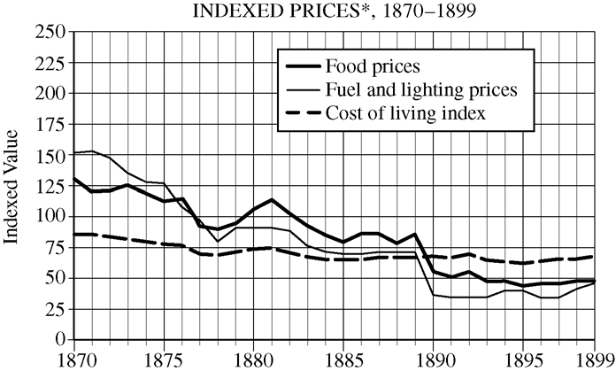
*Indexed prices refers to the average prices for goods and services during a given interval of time.
Document 2
Source: Andrew Carnegie, “Wealth,” North American Review, June 1889.
This, then, is held to be the duty of the man of Wealth: First, to set an example of modest, unostentatious living, shunning display or extravagance; to provide moderately for the legitimate wants of those dependent upon him; and after doing so to consider all surplus revenues which come to him simply as trust funds, which he is called upon to administer, and strictly bound as a matter of duty to administer in the manner which, in his judgment, is best calculated to produce the most beneficial results for the community—the man of wealth thus becoming the mere agent and trustee for his poorer brethren, bringing to their service his superior wisdom, experience, and ability to administer, doing for them better than they would or could do for themselves.
Document 3
Source: Theodore Dreiser, Sister Carrie, a novel, 1900.
[Department stores] were along the line of the most effective retail organization, with hundreds of stores coordinated into one and laid out upon the most imposing and economic basis. They were handsome, bustling, successful affairs, with a host of clerks and a swarm of patrons. Carrie passed along the busy aisles, much affected by the remarkable displays of trinkets, dress goods, stationery, and jewelry. Each separate counter was a showplace of dazzling interest and attraction. She could not help feeling the claim of each trinket and valuable upon her personally.

Document 4
Source: Female typists, circa 1902.
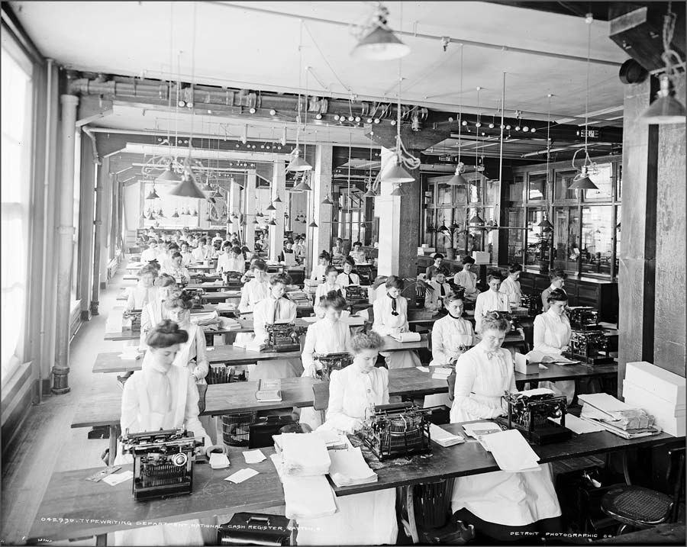

Document 5
Thomas Nast, “Always killing the goose that lays the golden egg”

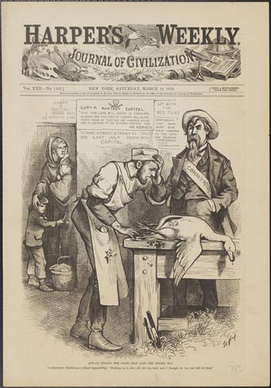

Document 6
William Graham Sumner, Forum, 1884

“The captains of industry and the capitalists…if they are successful, win, in these days, great fortunes in a short time. There are no earnings which are more legitimate or for which greater services are rendered to the whole industrial body…millions more of wealth, many fold greater than their own, scattered in the hands of thousands, would not exist but for them.”

Document 7
Source: George E. McNeill, labor leader, The Labor Movement: The Problem of Today, 1887.
The railroad president is a railroad king, whose whim is law. He collects tithes by reducing wages as remorselessly as the Shah of Persia or the Sultan of Turkey, and, like them, is not amenable to any human power. He can discharge (banish) any employee without cause. . . . He can withhold their lawful wages. He can delay trial on a suit at law, and postpone judgment indefinitely. He can control legislative bodies, dictate legislation, subsidize the press, and corrupt the moral sense of the community. He can fix the price of freights, and thus command the food and fuel-supplies of the nation. In his right hand he holds the government; in his left hand, the people.
Document 8
Source: Joseph Keppler, “The Bosses of the Senate,” Puck, January 23, 1889.
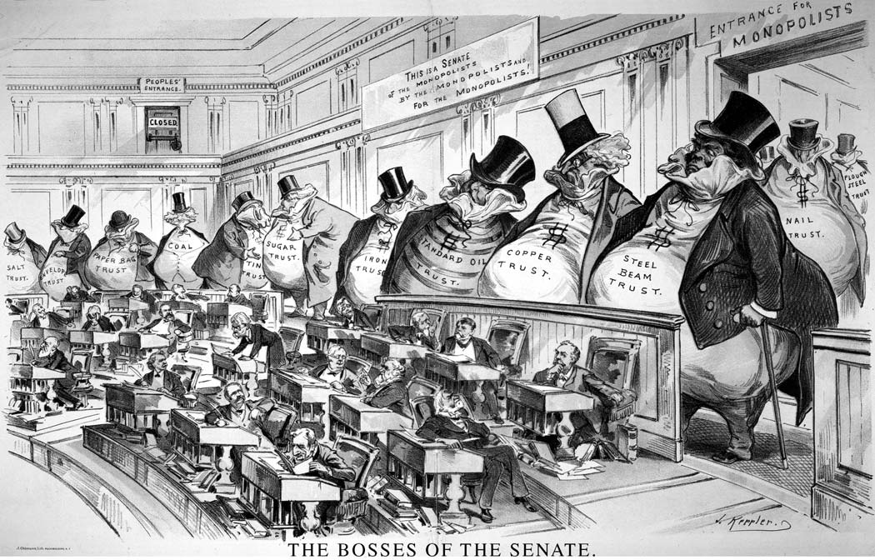

Document 11
Source: Samuel Gompers, What Does Labor Want?, an address before the International Labor Congress in Chicago, August 28, 1893.
The organized working men and women, the producers of the wealth of the world, declare that men, women and children, with human brains and hearts, should have a better consideration than inanimate and dormant things, usually known under the euphonious title of “Property.”. . .
We demand a reduction of the hours of labor, which would give a due share of work and wages to the reserve army of labor and eliminate many of the worst abuses of the industrial system now filling our poor houses and jails. . . .
Labor . . . insists upon the exercise of the right to organize for self and mutual protection. . . . That the lives and limbs of the wage-workers shall be regarded as sacred as those of all others of our fellow human beings; that an injury or destruction of either by reason of
negligence or maliciousness of another, shall not leave him without redress simply because he is a wage-worker. . . .
And by no means the least demand of the Trade Unions is for adequate wages.
Document 12
Source: Breaker Boys at Woodward Coal Mining, Kingston, Pennsylvania, c. 1900.

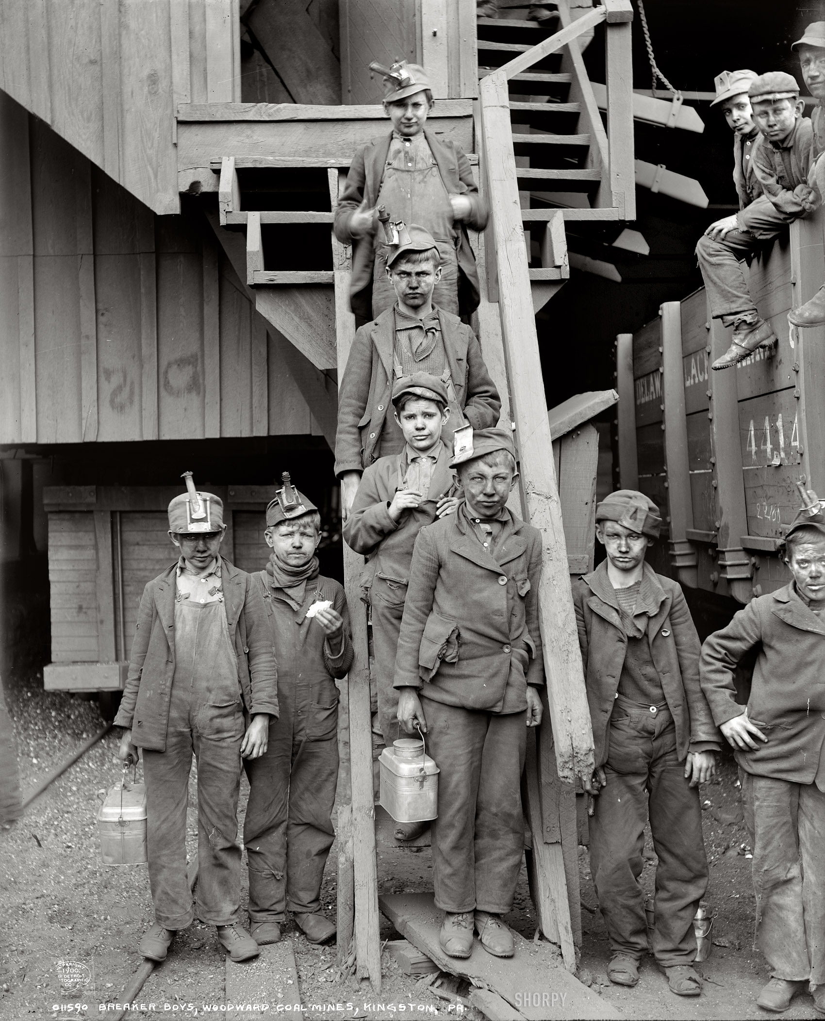

SHORT ANSWER: ROBBER BARONS OR CAPTAINS OF INDUSTRY

“They were aggressive men, as were the first feudal barons; sometimes they were lawless; in important crises, nearly all of them tended to act without those established moral principles which fixed more or less the conduct of the common people of the community.... These men were robber barons as were their medieval counterparts, the dominating figures of an aggressive economic age.... Under their hands, the renovation of our economic life proceeded relentlessly; large-scale production replaced the scattered, decentralized mode of production; industrial enterprises became more concentrated, more ‘efficient’ technically, and essentially ‘cooperative,’ where they had been purely individualistic and lamentably wasteful.”

Matthew Josephson, historian, 1934

“What really lifted the giants above the rest was the ability to envision where the world, or their part of it, was going, and to act on that vision in a creative way.... From the days of Adam Smith, self-interest has been the acknowledged driving force of capitalism; the secret of the market system is that one person’s self-interest can simultaneously serve the interests of others. Buyers and sellers, producers and consumers,
investors and entrepreneurs take reciprocal advantage of each other. Success rewards those who can discover or create areas of reciprocity; the larger the area, the greater the success.... They were captains of industry; but like officers of volunteer regiments, they held their posts at the sufferance of those they led.”

H. W. Brands, historian, 1999

SHORT ANSWER: ROBBER BARONS OR CAPTAINS OF INDUSTRY
Answer parts a,b, and c.
- Briefly explain ONE major difference between Josephson’s and Brand’s interpretations.
- Provide and explain ONE specific piece of historical evidence not directly mentioned in the excerpt which supports the first author.
- Provide and explain ONE specific piece of historical evidence not directly mentioned in the excerpt which supports the second author.

