Period 9 (1980 – Present) Review Sheet

Welcome to Period 9! This period is the last period and is roughly 5% of the APUSH curriculum.
C
H
E
C
K

I
T

O
U
T
!

Potential Short Answer Questions/Essay Topics Include:
- Just like period 1, you will not see a Long Essay or DBQ exclusively on this time period. You could see this time period combined with period 8, as was the case of the DBQ in 2015 on the rise of Conservatism.
- Reasons for the rise of Conservatism
- Impact of the end of the Cold War (Short Answer Question)

Why were these years chosen for this period?
1980 ushered in a Conservative Movement with the election of Ronal Reagan. The US increasingly traded with other countries as the world became more globalized. The 1990s was a prosperous time for many Americans and the 21st century saw the US involvement in the Middle East increase as a result of 9/11.

Key vocabulary terms to know for this time period:
Check the following terms out on Quizlet HERE

Foreign Policy “Failures”: Helped lead to public distrust in government; example is Iran Hostage Crisis
Taxation and deregulation as victories for conservatives: Tax rates decreased under Ronald Reagan and government regulation of businesses decreased as well
Denouncing “Big Government”: Reagan criticized the growth of the federal government over the previous years (Great Society)
Reagan Administration: Elected in 1980, focused on denouncing "Big Government", decreasing taxes, increased military spending
Mikhail Gorbachev: Soviet leader that saw improved relations with Reagan, instituted glasnost and perestroika which helped lead to the downfall of the Soviet Union
9/11 attacks on the World Trade Center and Pentagon: Led to the war in Afghanistan, increased US involvement in the Middle East
Conflicts in Afghanistan and Iraq: Afghanistan - response to 9/11; Iraq - concerns over WMDs and terrorism (no WMDs were found); both resulted in prolonged wars
War on terrorism: Response to 9/11, US would actively fight terrorism throughout the world
Free Trade Agreements: Goal is to increase trade among countries by reducing tariffs (NAFTA - no tariffs between US, Canada, and Mexico)
Concerns over climate change: Continuing of the environmental movement of the 1960s and 1970s. Debates over sources of energy

Hold Up!

Watch THIS (https://www.youtube.com/watch?v=BR9UilvsIr8) video on Period 8 before you proceed. (10 minutes)

1. Identify and describe three reasons for the growth of conservatism:
1.
2.
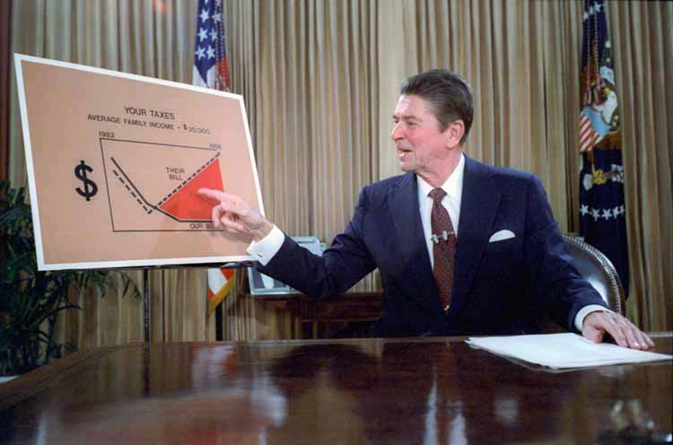
3.

2. What were two successes of the conservative movement?
1.
2.

3. What were two failures of the conservative movement?
1.
2.

4. During Ronald Reagan’s first term, did he continue, or change relations with the Soviet Union? Provide an example to support your answer.

5. How did Reagan and Mikhail Gorbachev improve relations between the US and USSR?
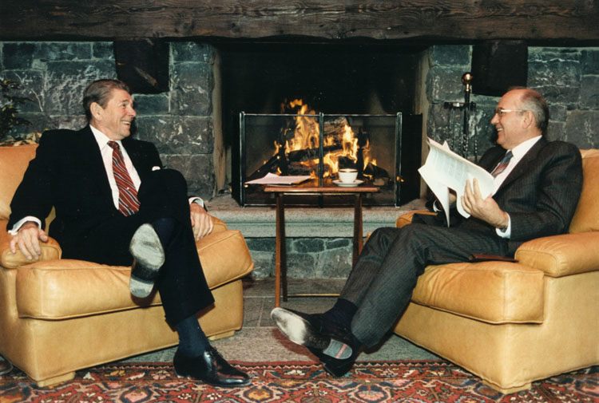
6. Identify and describe two military and peacekeeping interventions the US participated in after the end of the Cold War.

7. What has happened to many manufacturing jobs after 1980?

8. What is the “rust belt”?

9. What did the North Atlantic Free Trade Agreement do? Why were there debates over this agreement?

11. How has immigration changed since 1965?

12. Quick connection – what happened to immigration in the 1920s?

13. Why has the environment been a concern since the 1980s?

14. Why did the US engage in a conflict in Afghanistan?

15. Why did the US engage in a conflict in Iraq?

16. How has the war on terrorism led to debates over civil liberties?

Document Analysis
“You and I, as individuals, can, by borrowing, live beyond our means, but for only a limited period of time. Why, then, should we think that collectively, as a nation, we are not bound by that same limitation?......
…..In this present crisis, government is not the solution to our problem; government is the problem…..
…..It is no coincidence that our present troubles parallel and are proportionate to the intervention and intrusion in our lives that result from unnecessary and excessive growth of government.”
- Ronald Reagan’s Inaugural Address, 1981
(Check out THIS (https://www.youtube.com/watch?v=57l78DuPaHs) video for a quick review.)
Document Analysis And Other Questions

1. What government “intervention and intrusion” did conservatives such as Reagan criticize?

2. What led to increased government spending in the 1960s and 1970s?

3. What were economic impacts of this spending in the 1970s and early 1980s?

HIPP Analysis

1. What is the Historical Circumstance of this document?

2. Who is the Intended Audience of this document?

3. What is the Point of View of the document?

4. What is the Purpose of this document?

“We welcome change and openness; for we believe that freedom and security go together, that the advance of human liberty can only strengthen the cause of world peace. There is one sign the Soviets can make that would be unmistakable, that would advance dramatically the cause of freedom and peace. General Secretary Gorbachev, if you seek peace, if you seek prosperity for the Soviet Union and Eastern Europe, if you seek liberalization, come here to this gate. Mr. Gorbachev, open this gate. Mr. Gorbachev, tear down this wall!”
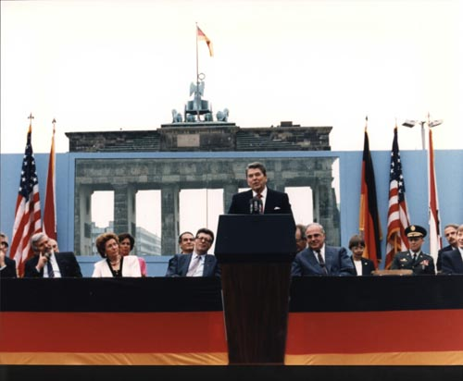
- Ronald Reagan, June 12, 1987
(Check out THIS (https://www.youtube.com/watch?v=YNauM4uBMRc) video for a quick review.)

HIPP Analysis
1. What is the Historical Circumstance of this document?

2. Who is the Intended Audience of this document?

3. What is the Point of View of the document?

4. What is the Purpose of this document?

“We will starve terrorists of funding, turn them one against another, drive them from place to place, until there is no refuge or no rest. And we will pursue nations that provide aid or safe haven to terrorism. Every nation, in every region, now has a decision to make. Either you are with us, or you are with the terrorists. From this day forward, any nation that continues to harbor or support terrorism will be regarded by the United States as a hostile regime.”
- George W. Bush Address To Congress, September 20, 2001
(Check out THIS (https://www.youtube.com/watch?v=eoS3SRTvngs) video for a quick review.)

HIPP Analysis

1. What is the Historical Circumstance of this document?

2. Who is the Intended Audience of this document?

3. What is the Point of View of the document?

4. What is the Purpose of this document?

