Political Cartoon Analysis
What do you see in the political cartoon?

Which of these are symbols and what do they represent?

What is the historical context of this cartoon?

Who is the audience of this cartoon?

What is the purpose of this cartoon?

What is the point of view of the artist in regards to the subject of the cartoon?

Why is this cartoon significant?

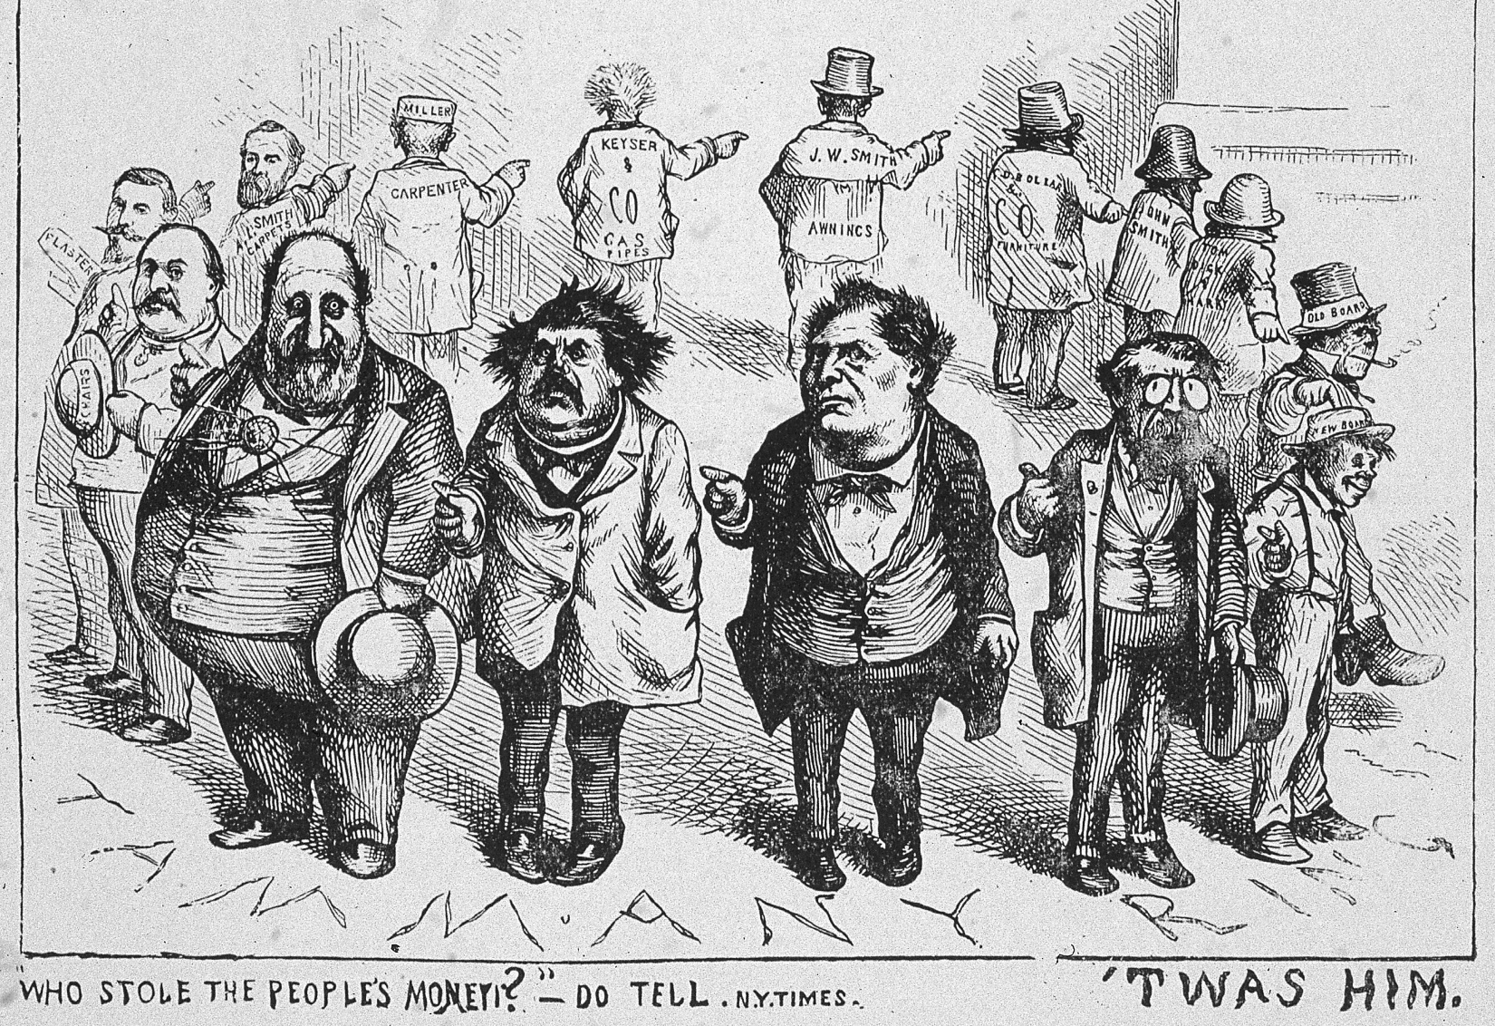
Political Cartoon Analysis
What do you see in the political cartoon?

Which of these are symbols and what do they represent?

What is the historical context of this cartoon?

Who is the audience of this cartoon?

What is the purpose of this cartoon?

What is the point of view of the artist in regards to the subject of the cartoon?

Why is this cartoon significant?

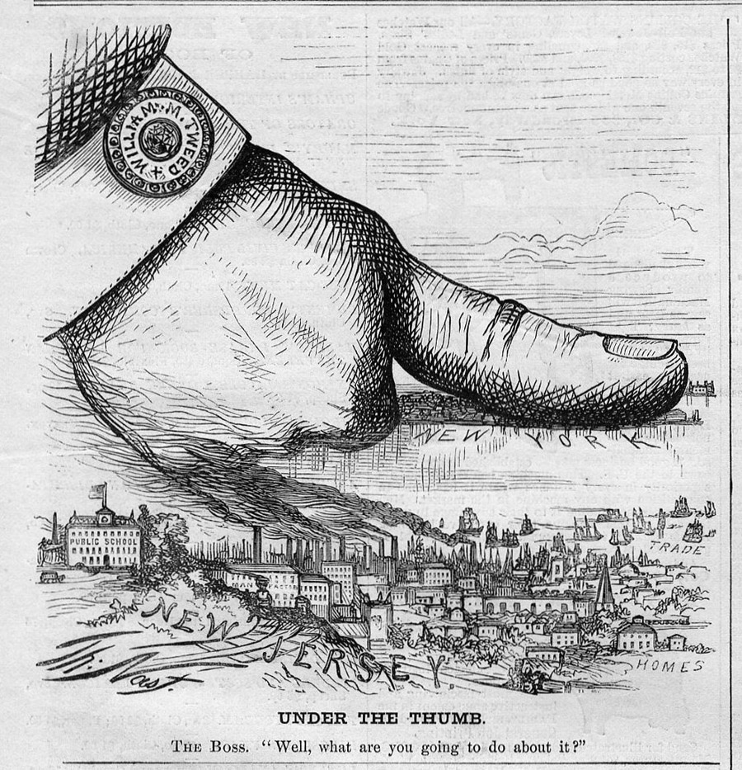

Political Cartoon Analysis
What do you see in the political cartoon?

Which of these are symbols and what do they represent?

What is the historical context of this cartoon?

Who is the audience of this cartoon?

What is the purpose of this cartoon?

What is the point of view of the artist in regards to the subject of the cartoon?

Why is this cartoon significant?

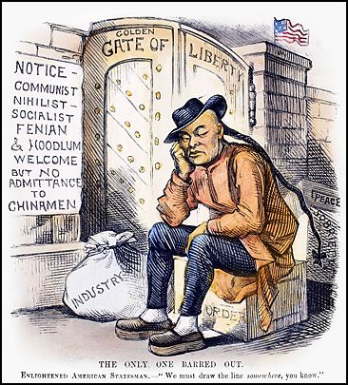

Political Cartoon Analysis
What do you see in the political cartoon?

Which of these are symbols and what do they represent?

What is the historical context of this cartoon?

Who is the audience of this cartoon?

What is the purpose of this cartoon?

What is the point of view of the artist in regards to the subject of the cartoon?

Why is this cartoon significant?

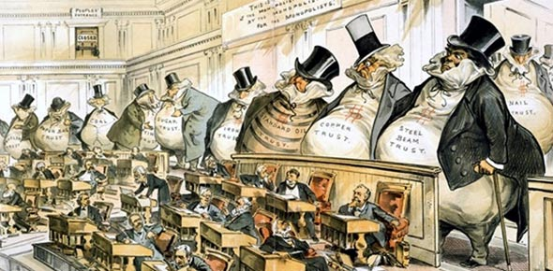

Political Cartoon Analysis
What do you see in the political cartoon?

Which of these are symbols and what do they represent?

What is the historical context of this cartoon?

Who is the audience of this cartoon?

What is the purpose of this cartoon?

What is the point of view of the artist in regards to the subject of the cartoon?

Why is this cartoon significant?

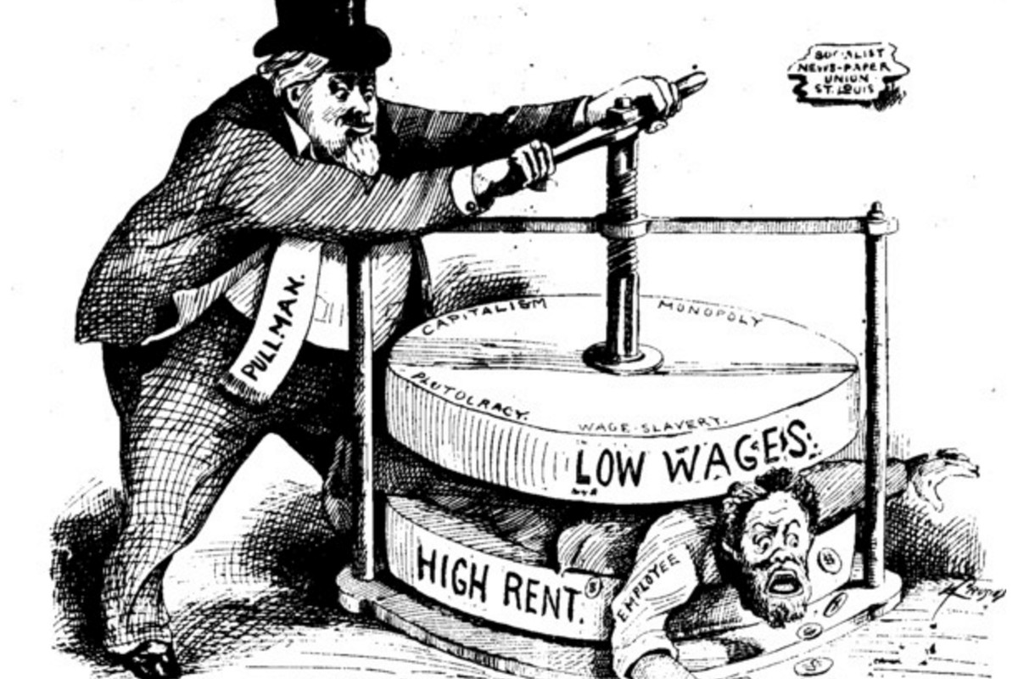
Political Cartoon Analysis
What do you see in the political cartoon?

Which of these are symbols and what do they represent?

What is the historical context of this cartoon?

Who is the audience of this cartoon?

What is the purpose of this cartoon?

What is the point of view of the artist in regards to the subject of the cartoon?

Why is this cartoon significant?

