Puppet Project:
Due: Monday, May 20
Worth: 100 points
Materials Needed:
- lunch sized paper bag
Art supplies; fabric, glue, yarn, buttons, markers, colored pencils etc.

Information Needed:
Topic - Sign up for a topic/person – They have to be someone who affected US History in some way and preferably that they lived in America. There can be no repeats in a class period!
Who: The topic; personal info – birth, death, city of birth, status in life- king, politician, priest, lawyer, chief etc.
What: What did this person do that was historically significant?
Where: Where did the major historical occurrence(s) happen (country, region, continent, globally)?
When: When did the major historical occurrence(s) take place?
Why: Why? What was/were the reason(s) that the historical occurrence(s) happened?
How: How is this figure significant to US History?
Quote: suggestion to google the person’s name + quote (e.g. Napoleon Bonaparte quotes)

Assembly:
Quote
Let them eat cake!

The front: should resemble the person you have selected- hair & facial hair, clothing style
The Quote: should be written in the fold where the mouth is.

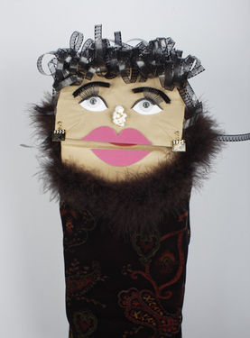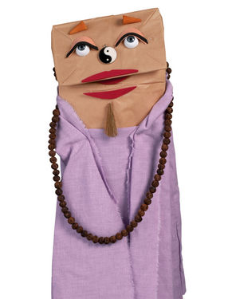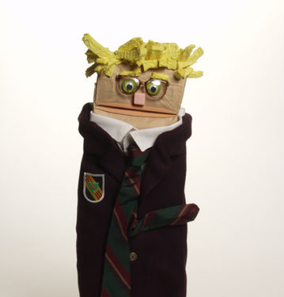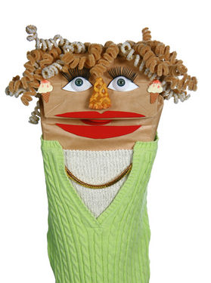

The back: should portray the information that you’ve collected in a neat & orderly fashion.

The bottom/attached to inside: should have your work cited page in proper MLA formatting (MLA citations in alphabetical order)

Presentation: You or your puppet must share information about him/herself to the class for the purpose of review

Top of the bag
How
Bottom of the bag
Who
When
Where
What

Why

You will be graded on the following:
Excellent: 100-95
Good: 94 - 85
Satisfactory: 84 - 75
Poor: 74 - 65
Unacceptable: 65-50

Organization and Creativity: Extremely well designed. Attention to detail in the design of your puppet. It should be clear who you are trying to represent and should be neatly crafted. General appearance is engaging to the viewer.

Content: Completely accurate; all facts are precise and explicit; author conveys a knowledge of the person and their significance to US History.

Research: Went above and beyond to research info; utilized both primary and secondary sources; solicited material in addition to that which would be readily available in a text or general reference. Research was balanced and thorough for all major features of the project

Mechanics: All written work follows the conventions for standard English grammar, syntax and spelling. PROPER MLA FORMAT and CITATIONS. Incorrect or missing format = F=ZERO

