Six Degrees of Separation
Directions: In the event boxes, list six relevant events in chronological order. In the space between the chronological events, explain how each event is related to the next event in the sequence. After completing this task, write a brief statement (full sentences) that explains the relationship of the event arc to the concept / learning objective.

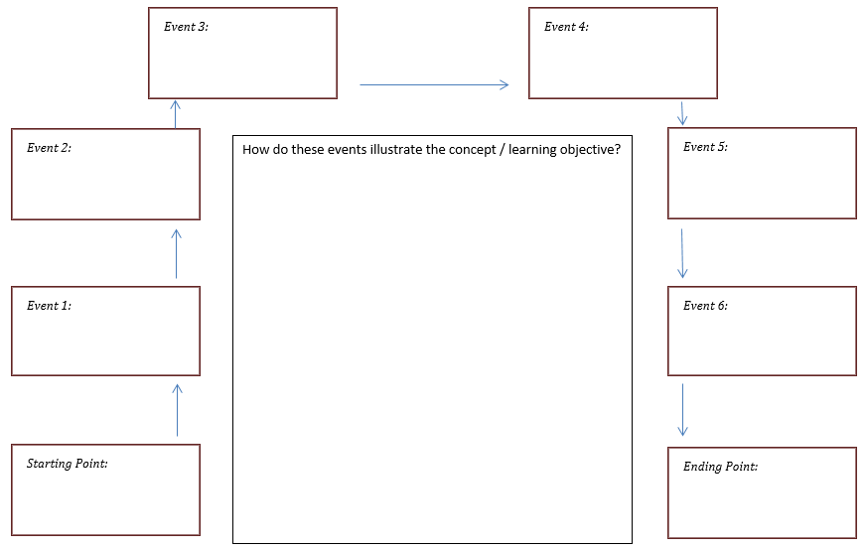
Concept / Learning Objective: Explain how and why the US entered WWI.

